`

Porject Guided By: Mr Akash Padhiyar



A Project Submitted to

Noble University

Faculty Of MCA

Project Report on



Project Developed By:

Sohil Vora - 220441025

Zaid Vora - 220441024

2024

**Certificate**

This is to certify that the Project report entitled

**____________________________________** is a bonafide record of research work done by ______________________________ __________________________________

Enrollment No.: __________________ __________________ under my supervision and submitted to **Noble University** in partial fulfilment for MASTER OF COMPUTER APPLICATION (MCA) SEMESTER 4.

**Signature of the Guide**

**Designation:**

**PREFACE**

There is a wide difference between theory and practical. If one has only theoretical background of any subject, one would not succeed in own aim therefore it is necessary for any person to have adequate practical knowledge of the concerned subject. As I know MCA is a course based on “Information Technology” and it is totally practical field. With only theoretical knowledge one can’t be succeeded or one can’t be on the peak position.

In the course of MCA designed by the “Noble University” they have taken full care of these things and designed the course in such a manner with which student can get theoretical and practical both type of knowledge perfectly. According to the rules & regulation of “Web Development”, we have a subject named “INDUSTRIAL TRAINING”. In which we have to create a web project of any institute or industry.

As a MCA student, I have gathered general information about E-Commerce Site. Then I decided to develop the site for Ecommerce site for shopping. In this site you can you can buy many new product as well as you can return the product as per company police. You can also put the advertisement on this site.

In this project report I have covered all the information, which is required for the web project of MCA student.

I have tried as my best present this project report in such a way that it makes easy to understand the project work.

**ACKNOWLEDGEMENT**

Much happy to present this “Project Report”. Before you, expecting that you will acknowledgement it. It is a matter of great pleasure for me that I had an opportunity to express our view on the same.

As a part of our academic study as the student of 4th semester of MCA I am required to undergone training software project an institute or industry in order to obtain practical knowledge and broaden our regarding the same.

At first, I would like to express our & humble thanks & gratitude to the who has provided us such a great, Co- operative & progressive environment.

Secondly at this moment, I would like to express our deepest sense of gratitude to our professor as well as project guides “Mr Uday Shah” and who have contributed their precious time for the purpose of giving us the correct information with special interest & guidance throughout our project work.

I am also thankful to our classmate and few others who helped me directly or indirectly in solving problem & in making our software project more efficient & good working.

**INDEX**

|  |  |  |
| --- | --- | --- |
| Serial no. | Title | Page no. |
| 1. | **Introduction and objective of project** | 1 – 2 |
|  | | |
| 2. | **Tools or Platform** | 3 |
| 2.1 | Hardware & software Requirement Detail | 3 |
|  | | |
| 3. | **Problem Definition** | 4 |
| 3.1 | Requirement Specification | 4 |
|  | | |
| 4. | **System analysis** | 5-33 |
| 4.1 | Identification of needs | 5 |
| 4.2 | Preliminary investigation Feasibility Study | 9 |
| 4.3 | Feasibility Study | 10 |
| 4.4 | Project planning | 12 |
| 4.5 | Project Scheduling (PERT Chart and Gantt Chart Both). | 13 |
| 4.6 | Software Requirement Specification | 15 |
| 4.7 | Data Models | 21 |
| 4.8 | Use Case Diagram | 28 |
| 4.9 | Activity Diagram | 31 |
|  | | |
| 5. | **System Design** | 34-48 |
| 5.1 | Table Detail | 34 |
| 5.2 | Database Diagram | 36 |
| 5.3 | User Interface Design | 38 |
|  | | |
| 6. | **Coding** | 49-53 |
| 6.1 | Complete Project Coding | 59 |
|  | | |
| 7. | **Testing** | 54-72 |
| 7.1 | Techniques and Strategies | 54 |
| 7.2 | Cost Estimation Model | 58 |
| 7.3 | SDLC Model | 61 |
| 7.4 | Future Scope and Further enhancement of the Project | 70 |
| 7.5 | Bibliography | 71 |
| 7.6 | Appendices | 72 |
| 7.7 | Glossary | 72 |

**Chapter – 1 Introduction And Objective Project**

1.1. Existing System

1.2. Need for the New System

1.3. Objective of the New System

1.4. Problem Definition

1.5. Core Components

1.6. Project Profile

1.7. Assumptions and Constraints

1.8. Advantages and Limitations of the Proposed System

Introduction

The E Mart System is design & developed for to manage their records for selling and purchasing of the Electronic goods from dealers and sell them to the customers. This system make the work of the electric shopkeepers easy as keep all the records of the electric product and also keep the record of the product that sold by customers. In this project we can easily maintain system sales details.

The E Mart project is a multi-user system. It has been developed in a way that allows user to perform the function smoothly. The system is developed in PHP-MySql and some other software used. The system maintains the data of the electric goods And provides a best product to buy.

The report of this system is important. It provides information about the ‘E Mart. Hence our system gives the complete information of the ‘electric item’ at a glance.

This system is prepared in order to give all the information about electronic items and also for getting of the whole specifications. Our system also contains the data storage like user information, Electronic item information and also brands of the Electronic Items.

1.1. Existing System

Here's a summary of an electronic shop's operations without the use of Ecommerce Paltform:

* **Overview:** An electronic shop without the use of ecommerece plate form operates through traditional, manual methods for selling electronic products. The shop relies on in-person transactions, paper-based records, and face-to-face customer service.
* **Product Display:** Electronic products are displayed on shelves or tables in the shop, allowing customers to browse the available items in person.
* **Inventory Management:** Inventory is tracked manually, often using written records or physical counts.
* **Sales Transactions:** Sales are completed in person at a cash register, where customers pay using cash, checks, or possibly credit cards if a manual imprinting machine is available.
* **Order Management:** Orders may be taken in person or over the phone and recorded on paper. Fulfillment is handled manually, including picking items from the shelves and coordinating shipping if necessary.
* **Record Keeping:** Transactions and customer information are recorded on paper, such as sales receipts, invoices, and other documentation.
* **Physical Interaction:** Customers can physically examine products and ask questions in person before making a purchase.
* **Limitations and Challenges:**
* **Lack of Efficiency:** Manual record keeping and inventory management can be time-consuming and prone to human error.
* **Limited Reach:** Without an online presence, the shop's customer base is limited to those who visit the physical store.
* **Inconvenient Transactions:** Without digital payment systems, transactions may be slower and less flexible.
* **Challenges in Scalability:** Scaling up the business is challenging without computerized systems to streamline operations.

In summary, an electronic shop without ecommerce platform operates using manual, traditional methods for all aspects of its business, from sales and inventory management to customer service. This approach can offer personalized service but may face challenges in efficiency, scalability, and customer convenience.

1.2. Need for the New System

Here's a summary of the need for the new syatem for an electronic shop's e-commerce platform:

* **Overview:** The existing system is a web-based platform for the electronic shop that enables customers to browse and purchase electronic products online. It supports essential e-commerce features, including a product catalog, shopping cart, and checkout process.
* **Current Features and Functionalities:**
* **Product Catalog:** The system provides a digital catalog for customers to browse electronic products. It includes product descriptions, images, prices, and inventory information.
* **Search and Filtering:** Customers can search for specific products using keywords or categories and apply filters to narrow down options.
* **Shopping Cart and Checkout:** Customers can add products to a virtual cart and proceed through a checkout process, entering payment and shipping information.
* **Payment Processing:** The system integrates with a payment gateway to enable secure online transactions via credit/debit cards and other methods.
* **Order Management:** Once orders are placed, the system manages order tracking, updates, and fulfillment.
* **Customer Accounts:** Customers can create accounts to manage their orders, view order history, and save shipping and payment preferences.
* **Limitations and Challenges:**
* **Outdated Technology:** The system may be using outdated technology, affecting performance and scalability.
* **Limited User Experience:** The interface may be less user-friendly, lacking modern design and responsive elements for mobile devices.
* **Security Concerns:** There may be potential security vulnerabilities or data protection issues.
* **Inflexible Payment Options:** Limited payment methods and lack of integration with new payment gateways.
* **Lack of Advanced Features:** Missing advanced features such as personalized recommendations, advanced search options, and marketing tools.
* **User Feedback:** Customers may have provided feedback about slow page loading times, limited mobile compatibility, and difficulties with finding products or completing transactions.

This summary outlines the existing e-commerce system for the electronic shop, highlighting its features, strengths, and limitations. Understanding these aspects helps identify areas for improvement and the need for a new or updated system.

1.3. Objective of the New System

Here's a summary of the objective of the new e-commerce system for an electronic shop:

* **Enhanced User Experience:** The new system aims to provide a more intuitive and seamless shopping experience for customers. This includes a modern user interface, responsive design for mobile devices, and advanced search and filtering capabilities.
* **Improved Performance and Reliability:** The system will enhance performance through faster load times and more consistent uptime, ensuring customers can access the shop and complete transactions without interruptions.
* **Advanced Features and Functionalities:** The new system will offer a wider range of features such as personalized recommendations, targeted marketing tools, and a more efficient checkout process. This includes omnichannel capabilities for a consistent experience across multiple touchpoints.
* **Enhanced Security and Privacy:** Improved security measures, such as encryption and data protection protocols, will safeguard customer information and transactions. Compliance with privacy regulations will also be prioritized.
* **Diverse and Flexible Payment Options:** The new system will integrate with multiple payment gateways to offer customers a variety of payment methods, including digital wallets and alternative payment options.
* **Streamlined Order Management:** Order processing will be more efficient, including automated inventory management and real-time order tracking, resulting in faster and more accurate fulfillment.
* **Better Customer Support:** Improved customer support channels, such as live chat and comprehensive help centers, will enhance the overall shopping experience and address customer inquiries more effectively.
* **Analytics and Insights:** The system will collect and analyze data on customer behavior, sales, and other metrics to provide actionable insights for improving business strategies and operations.
* **Scalability and Flexibility:** The new system will be designed to accommodate business growth and adapt to changing market conditions, ensuring the shop remains competitive and can scale as needed.

In summary, the objective of the new e-commerce system is to enhance the electronic shop's operations by improving the user experience, performance, security, and operational efficiency. By offering advanced features and better support, the new system aims to increase customer satisfaction, loyalty, and sales while positioning the shop for long-term success.

1.4. Problem Definition

Here is a summary of the problem definition for an electronic shop's existing e-commerce system:

* **Outdated Technology:** The existing e-commerce system relies on outdated technology, which leads to various performance issues, including slow load times and occasional system crashes. This can negatively impact customer satisfaction and overall sales.
* **Limited Features and Functionalities:** The current system may lack modern e-commerce features such as advanced search options, personalized recommendations, and targeted marketing tools. This limits the shop's ability to provide a seamless and engaging shopping experience for customers.
* **Poor User Experience:** The user interface of the existing system may be cumbersome, outdated, or not optimized for mobile devices. This can make it difficult for customers to navigate the site, find products, and complete purchases.
* **Security Concerns:** Potential security vulnerabilities in the existing system may put customer data and transactions at risk. Lack of compliance with data protection regulations can also pose legal and reputational risks.
* **Inflexible Payment Options:** The existing system may offer a limited range of payment options, which can inconvenience customers and lead to abandoned carts and lost sales.
* **Inefficient Order Management:** Manual or inefficient order management processes can result in delays, errors, and dissatisfied customers. The existing system may lack automation for order processing, inventory management, and tracking.
* **Challenges with Scalability:** The existing system may struggle to handle increased transaction volumes and business growth. This can hinder the shop's ability to expand and meet changing market demands.
* **User Feedback:** Feedback from customers may highlight issues such as difficulty finding products, completing purchases, and navigating the site. Negative customer experiences can lead to reduced customer loyalty and retention.

In summary, the existing e-commerce system for the electronic shop faces several challenges, including outdated technology, limited features, poor user experience, and security concerns. These issues affect the shop's ability to provide a seamless shopping experience, efficiently manage operations, and scale to meet future growth. Addressing these problems is essential for the shop's success and competitiveness in the e-commerce market.

How It Works

In this project first of all a homepage is displayed for visitors those who are not registered. E Mart provide them limited information about electronic items, specifications options etc.

Secondly, there is a user homepage which a user can see if he is registered at E Mart. This transaction is maintained by the login form. It will add the particular user in database. If user wants to buy item from our website then he must compulsory register. Users have to login with Email & Password. If the person is not a user, then he has to click on the register button and must fill all the fields completely in registration form.

After login, there will be a Home page of ‘E Mart’ Website. There are various menus for example categories, shop, etc. . . .

After registering in our website user can follow the steps prompted by the website and get a payment method complete then users’ product is shipped.

After item shipped if user can cancel order if user want’s, that can perform simply click on cancel order in my order page. As well as after delivered the item user can return the ordered items if user want’s as per company guidelines

**Chapter – 2 Tools and Platform**

2.1 Hardware & Software Requirement Detail

2.2 Requirement Specification

Requirement Details

* Title : E Mart
* Hardware Requirements

Processor : I3 or higher

Ram : 4 GB(Minimum)

Hard Disk : 120 GB (Minimum)

* Tools Used

Front End : HTML, CSS, JS, BootStrap,

Ajax, jQuery

Back End : PHP, MYSQL

Operating System : Windows 8 or Higher

* Software Requirement

Xampp/Wampp Server

Google Chrome

VS Code or other code editor

**Chapter – 3 Problem Specification**

Requirement Specification

E Mart provides you a platform to buy Eletronic items. Customer through the products page and the items to shopping cart. Customer can proceed to checkout as long as his shopping cart is checkout, or he can create an account if he not yet have one.

If customer want to buy any product then he will loged in into a site. if customer don’t have an account then he need to create. In creating account customer need to fill some information as like, name, email, contact No. etc…

After creating an account or loged in customer can procede to check out that means to buy a product. Customer can pay amount with any payment method as like Debit Card, Creadit Card, Internet Banking, or Cash On delivery. If customer choose cash on delivery then will charged.

**Chapter – 4 System Analysis**

4.1 Identification of needs

4.2 preliminary investigation Feasibility study

4.3 Feasibility Study

4.4 Project Planning

4.5 Project Scheduling (PERT Chart and Gantt chart)

4.6 Software Requirement Specification

4.7 Data Model

4.8 Usecase Diagram

4.9 Activity Diagram

4.1 Identification of Needs

* The viewer of our system doesn’t need to login as long he only browse various information. But if customer wants to buy any product then he must be registered on our website.
* Visitors need to provide full name, email address, Mobile No. etc… details for creating an account.

SDLC Model

**Quick Design**

**Define Requirement**

**Build Prototype**

**Customer Evaluation of Design**

**Quick Design**

**Implementation**

**Testing**

**Requirement Gathering**

**Maintenance**

SDLC Steps

* Requirement gathering
* Requirement specification and analysis
* Design
* Coding
* Testing
* Maintenance

Requirement Gathering

In this phase of SDLC necessary information are collected. We collect the information in this phase through questionnaire shopkeepers and online websites also. We are also note down the requirements of the clients.

Requirement Specification and analysis

The requirements are being specify in this phase. Analyst checks how the current system is working and then plans how to develop the proposed system and implement it.

Design

In this phase the design of both front-end and back-end is decided. In this phase we using different graphically software like Macromedia Flash and Adobe Photoshop. And designing of tables are also done properly in this phase.

Coding

After the completion of designing there is a turn for coding. Coding is completed in various files. In most case coding takes the more time than the design.

Testing

In testing phase first unit level testing is done. In unit level testing the software is tested in an individual file. After the unit testing of each file the integration testing done. In integration testing the files are tested into their own package. At last, in the system testing the whole system is run on the INTERNET ENVIRONMENT.

Maintenance

The proper maintenance is given as indicate in the SRS (Software Requirement Specification). It is a responsibility of Developer to maintain the software during its criteria mentioned in SRS document.

4.2 Preliminary Investigation & Feasibility Study

**Our Objectives:**

* + Admin can add new, Delete and Edit records.
  + User can browse category wise.
  + User can handle all type of information easily
  + User can search through search bar.
  + Easy updating, time saving, quick process.
  + User can update their registration details.

**Platform Specification:**

* We have used windows based developing graphical based applications our software will provide support GUI efficiently. It must for our system because for our project.
* It is very useful and support of Java and Java Script control and component.
* Use of Table for menu create and display Form in it.
* It is easy to integrity database report use with Data Report.
* PHP platform is mostly use for development Web Based Application
* Regular version of operating system use with it.
* Always need to back end tool for developed web Application with front tool.

4.3 Feasibility Study

A feasibility analysis usually involves a thorough assessment of the operational (need), financial and technical aspects of a proposal. Feasibility study is the test of the system proposal made to identify whether the user needs may be satisfied using the current software and hardware technologies, whether the system will be cost effective from a business point of view and whether it can be developed with the given budgetary constraints. A feasibility study should be relatively cheap and done at the earliest possible time. Depending on the study, the decision is made whether to go ahead with a more detailed analysis.

When a new project is proposed, it normally goes through feasibility assessment. Feasibility study is carried out to determine whether the proposed system is possible to develop with available resources and what should be the cost consideration. Facts considered in the feasibility analysis were.

1. Technical Feasibility Study

* Technical feasibility is considered. In terms of technical requirements and their availability in the market. It determines whether the current level of technology supports the proposed system or not. The technical possibility of proposed system is as follows.
* The unit does possess the hardware as well as related software for the project.
* The proposed system does not require much technical detail.
* It just requires window operating system.
* The organization has already purchased all the enough devices for latest technical.
* These technical specifications are easily available in the market.
* Hence, the proposed system is technically feasible.

1. Economical Feasibility Study

Economic justification is generally the “Bottom Line” consideration for most systems. Economic justification includes a broad range of concerns that includes cost benefit analysis. In this we weight the cost and the benefits associated with the candidate system and if it suits the basic purpose of the organization i.e. profit making, the project is making to the analysis and design phase. The financial and the economic questions during the preliminary investigation are

**Verified to estimate the following:**

* The cost to conduct a full system investigation.
* The cost of hardware and software for the class of application being considered.
* The benefits in the form of reduced cost.
* The proposed system will give the minute information, as a result the performance is improved which in turn may be expected to provide increased profits.

This feasibility checks whether the system can be developed with the available funds. This can be done economically if planned judicially, so it is economically feasible. The cost of project depends upon the number of man hours required.

1. Operational Feasibility Study

* It is mainly related to human organizations and political aspects. The points to be considered are:
* What changes will be brought with the system?
* What organization structures are disturbed?
* What new skills will be required?
* Do the existing staff members have these skills? If not, can they be trained in due course of time?
* The system is operationally feasible as it very easy for the End users to operate it. It only needs basic information about Windows platform.

4.4 Project Planning

|  |  |  |  |  |
| --- | --- | --- | --- | --- |
| No. | Task Name | Start | Finish | Duration |
| **1** | Planning | 10/03/2023 | 16/03/2023 | 7 Days |
| **2** | Analysis | 17/03/2023 | 23/03/2023 | 7 Days |
| **3** | Designing | 24/03/2023 | 07/04/2023 | 15 Days |
| **4** | Coding | 08/04/2023 | 02/05/2023 | 25 Days |
| **5** | Implementation | 03/05/2023 | 10/05/2023 | 8 Days |
| **6** | Testing | 11/05/2023 | 10/05/2023 | 6 Days |
|  | Total |  |  | 68 Day |

4.5 Project Scheduling

**PERT CHART:**

This chart represents the development of our system Date wise.

Analysis

17/03 - 23/03

Planning

10/03 - 16/03

Designing

24/03 -07/04

Coding

08/04 -02/05

Implementation

03/05 -10/05

Testing

11/05 -16/05

Finish

**GANTT CHART:**

This is a graphical representation of the date wise development of our project system .It is very similar to the PERT chart except that it is represented graphically.

|  |  |  |  |  |  |  |  |  |  |  |  |  |
| --- | --- | --- | --- | --- | --- | --- | --- | --- | --- | --- | --- | --- |
| NO. | TASK NAME | Date From 1 - MArch - 2023 to 16 – May - 2023 | | | | | | | | | | |
| March – 2023 | | | | April – 2023 | | May – 2023 | | | | |
| 1 | Planning | 1 March to 16 March |  | | | | | | | | |
| 2 | Analysis |  | 17 March to 23 March |  | | | | | | | |
| 3 | Designing |  | | | 24 March to 07 April | |  | | | | |
| 4 | Coding |  | | | | | 08 April to 02 May | |  | | |
| 5 | Implementation |  | | | | | | | | 03 May to 10 May |  | |
| 6 | Testing |  | | | | | | | | | 11 May to 16 May | |

4.6 Software Requirement Specification

* 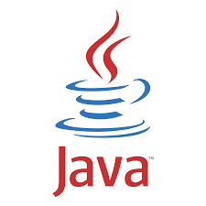**JSP :**

JavaServer Pages (JSP) is a technology for developing Webpages that supports dynamic content. This helps developers insert java code in HTML pages by making use of special JSP tags, most of which start with <% and end with %>.

A JavaServer Pages component is a type of Java servlet that is designed to fulfill the role of a user interface for a Java web application. Web developers write JSPs as text files that combine HTML or XHTML code, XML elements, and embedded JSP actions and commands.

Using JSP, you can collect input from users through Webpage forms, present records from a database or another source, and create Webpages dynamically.

JSP tags can be used for a variety of purposes, such as retrieving information from a database or registering user preferences, accessing JavaBeans components, passing control between pages, and sharing information between requests, pages etc.

JavaServer Pages often serve the same purpose as programs implemented using the **Common Gateway Interface (CGI)**. But JSP offers several advantages in comparison with the CGI.

Performance is significantly better because JSP allows embedding Dynamic Elements in HTML Pages itself instead of having separate CGI files.

JSP are always compiled before they are processed by the server unlike CGI/Perl which requires the server to load an interpreter and the target script each time the page is requested.

JavaServer Pages are built on top of the Java Servlets API, so like Servlets, JSP also has access to all the powerful Enterprise Java APIs, including **JDBC, JNDI, EJB, JAXP,** etc.

JSP pages can be used in combination with servlets that handle the business logic, the model supported by Java servlet template engines.

Finally, JSP is an integral part of Java EE, a complete platform for enterprise class applications. This means that JSP can play a part in the simplest applications to the most complex and demanding.

* 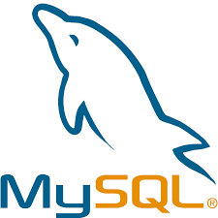**MYSQL :**

A database is a structured collection of data. It may be anything from a simple shopping list to a picture gallery or the vast amounts of information in a corporate network. To add, access, and process data stored in a computer database, you need a database management system such as MySQL Server. Since computers are very good at handling large amounts of data, database management systems play a central role in computing, as standalone utilities, or as parts of other applications.

If that is what you are looking for, you should give it a try. MySQL Server can run comfortably on a desktop or laptop, alongside your other applications, web servers, and so on, requiring little or no attention. If you dedicate an entire machine to MySQL, you can adjust the settings to take advantage of all the memory, CPU power, and I/O capacity available. MySQL can also scale up to clusters of machines, networked together.

MySQL Server was originally developed to handle large databases much faster than existing solutions and has been successfully used in highly demanding production environments for several years. Although under constant development, MySQL Server today offers a rich and useful set of functions. Its connectivity, speed, and security make MySQL Server highly suited for accessing databases on the Internet.

* 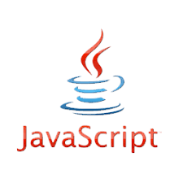**JavaScript :**

JavaScript was released by Netscape and Sun Microsystems in 1995.

* However, JavaScript is not the same thing as Java.
* It is a programming language.
* It is an interpreted language.
* It is object-based programming.
* It is widely used and supported
* It is accessible to the beginner.

**Uses of JavaScript :**

* Use it to add multimedia elements With JavaScript you can show, hide, change, resize images, and create image rollovers. You can create scrolling text across the status bar.
* Create pages dynamically Based on the user's choices, the date, or other external data, JavaScript can produce pages that are customized to the user.
* Interact with the user it can do some processing of forms and can validate user input when the user submits the form.
* **CSS:**
* A CSS (cascading style sheet) file allows you to separate your web sites (X)HTML content from its style.
* As always you use your (X)HTML file to arrange the content, but all of the presentation (fonts, colors, background, borders, text formatting, link effects & so on…) are accomplished within a CSS.
* At this point you have some choices of how to use the CSS, either internally or externally.
* **HTML:**

HTML stands for Hyper Text Markup Language.

* HTML is a language for describing web pages.
* HTML is a markup language.
* A markup language is a set of markup tags.
* The tags describe document content.
* HTML documents contain HTML tags and plain text.
* HTML documents are also called web pages.
* HTML markup tags are usually called HTML tags.
* HTML tags are keywords (tag names) surrounded by angle brackets like
* <html>.
* HTML tags normally come in pairs like <p> and </p>.
* The first tag in a pair is the start tag, the second tag is the end tag.
* The end tag is written like the start tag, with a slash before the tag name.
* Start and end tags are also called opening tags and closing tags.
* **Bootstrap:**



* BOOTSTRAP is a free and open-source CSS framework directed at responsive, mobile- first front-end web development.
* It contains HTML, CSS and JAVASCRIPT based design templates for typography, forms, buttons, navigation, and other interface components.

**Visitor User Admin Dataflow Diagram**

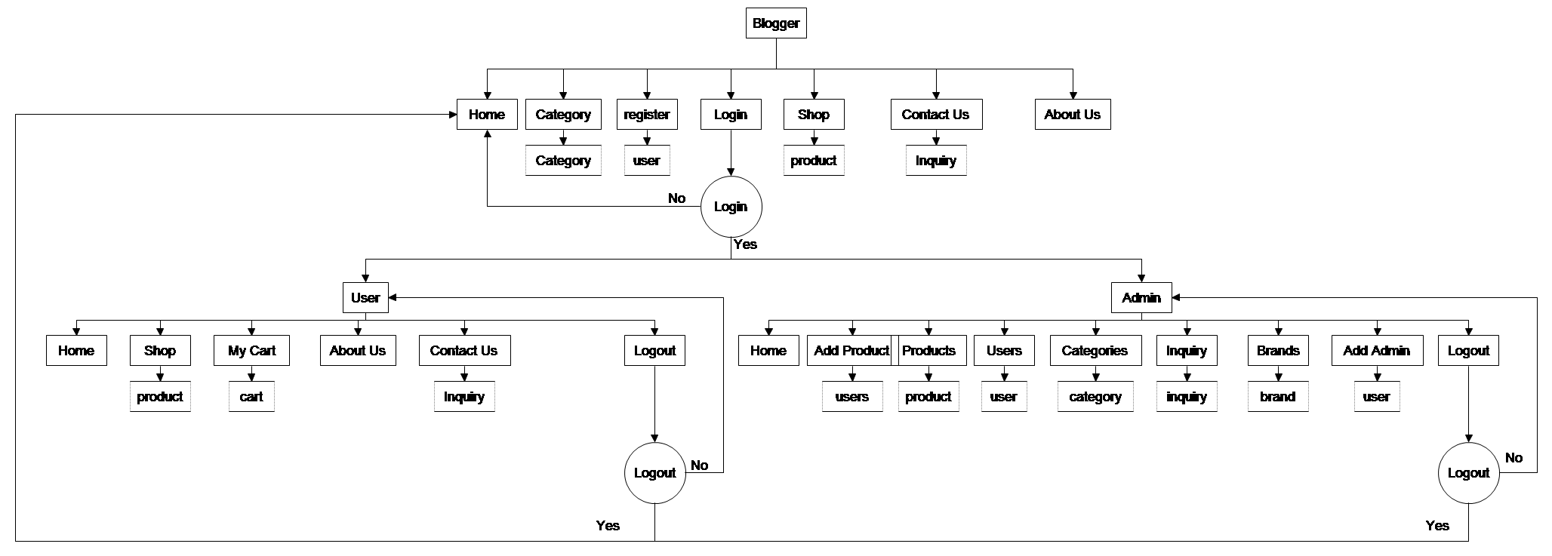

4.8 Usecase Diagram

* **Visitor Diagram:**



**Visitor**

**Shop byCategory**

**Shop**

**About Us**

**Contact Us**

**Login**

**Register**

**Home**

* **User Diagram:**



**Logout**

**Report**

**User**

**New Post**

**Home**

**My Post**

**My Profile**

**Contact Us**

**About Us**

* **Admin Diagram:**



**Logout**

**Category**

**Report**

**Add Admin**

**Post**

**User**

**Home**

**Admin**

4.9 Activity Diagram

Client is registered

Client’s Settings are displayed

Invalid Email / password

No

Client’s Settings are displayed

Client successfully logs in

YES

Correct Email and password ?

Client enters Email and password

Normalization

Normalization rule are divided into following normal form.

1. First Normal Form

2. Second Normal Form

3. Third Normal Form

1. **First Normal Form (1NF):**

As per First Normal Form, no two Rows of data must contain repeating group of information id each set of column must have a unique value, such that multiple columns cannot be used to fetch the same row. Each table should be organized into rows, and each row should have a primary key that distinguishes it as unique.

The **Primary key** is usually a single column, but sometimes more than one column can be combined to create a single primary key. For example consider a table which is not in First normal form.

1. **Second Normal Form (2NF):**

As per the Second Normal Form there must not be any partial dependency of any column on primary key. It means that for a table that has concatenated primary key, each column in the table that is not part of the primary key must depend upon the entire concatenated key for its existence. If any column depends only on one part of the concatenated key, then the table fails **Second normal form**.

Now, both the above tables qualifies for Second Normal Form and will never suffer from Update Anomalies. Although there are a few complex cases in which table in Second Normal Form suffers Update Anomalies, and to handle those scenarios Third Normal Form is there.

1. **Third Normal Form (3NF):**

**Third Normal form** applies that every non-prime attribute of table must be dependent on primary key, or we can say that, there should not be the case that a non-prime attribute is determined by another non-prime attribute. So this transitive functional dependency should be removed from the table and also the table must be in **Second Normal form**. For example, consider a table with following fields.

In this table Student_id is Primary key, but street, city and state depends upon Zip. The dependency between zip and other fields is called **transitive dependency**. Hence to apply **3NF**, we need to move the street, city and state to new table, with **Zip** as primary key.

The advantage of removing transitive dependency is,

* + - * Amount of data duplication is reduced.
      * Data integrity achieved.

**Chapter – 5 System Design**

5.1 Table Detail

5.1 Table Detail

5.2 Database Diagram

5.3 User Interface Design

1. **Register**

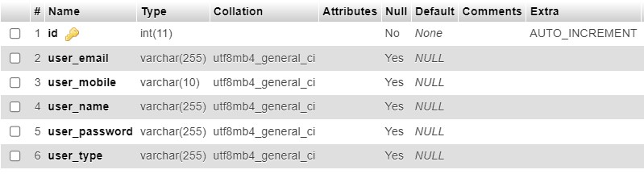

**2. Category**

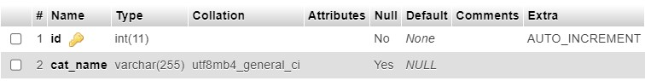

**3. Brand**

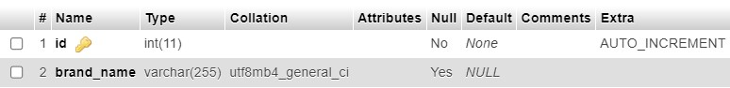

**4. Product**

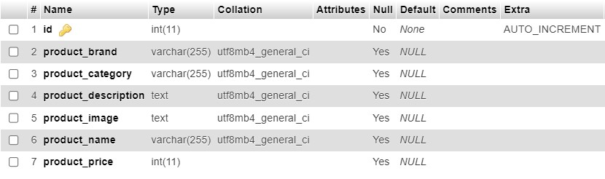

1. **Inquiry**

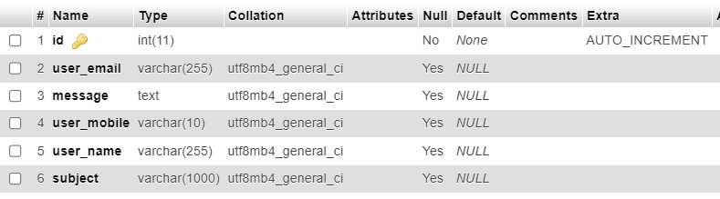

1. **Brand**

5.2 Database Diagram

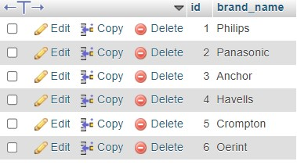

1. **Category**

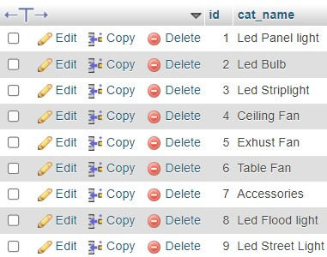

1. **Product**

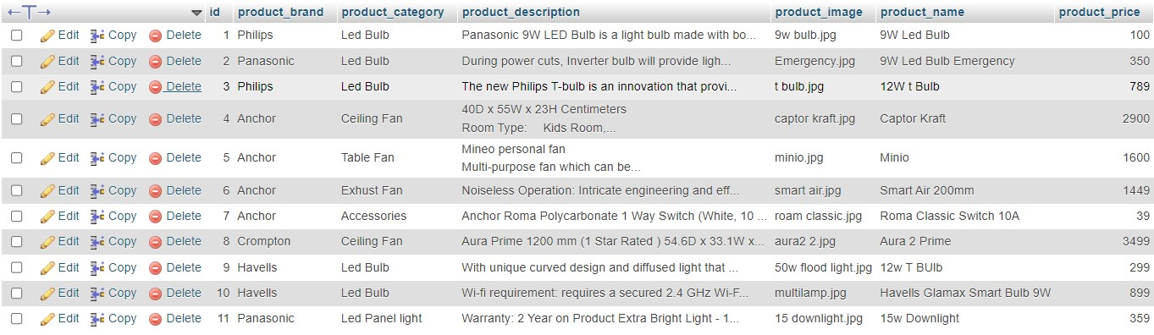

1. **User**

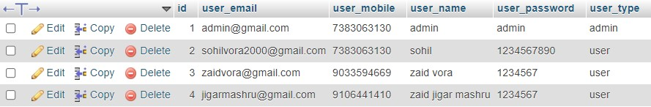

5.3 User Interface Design

Visitor

User

Admin

* **Visitor – Index :** This is Home page of visitor panel

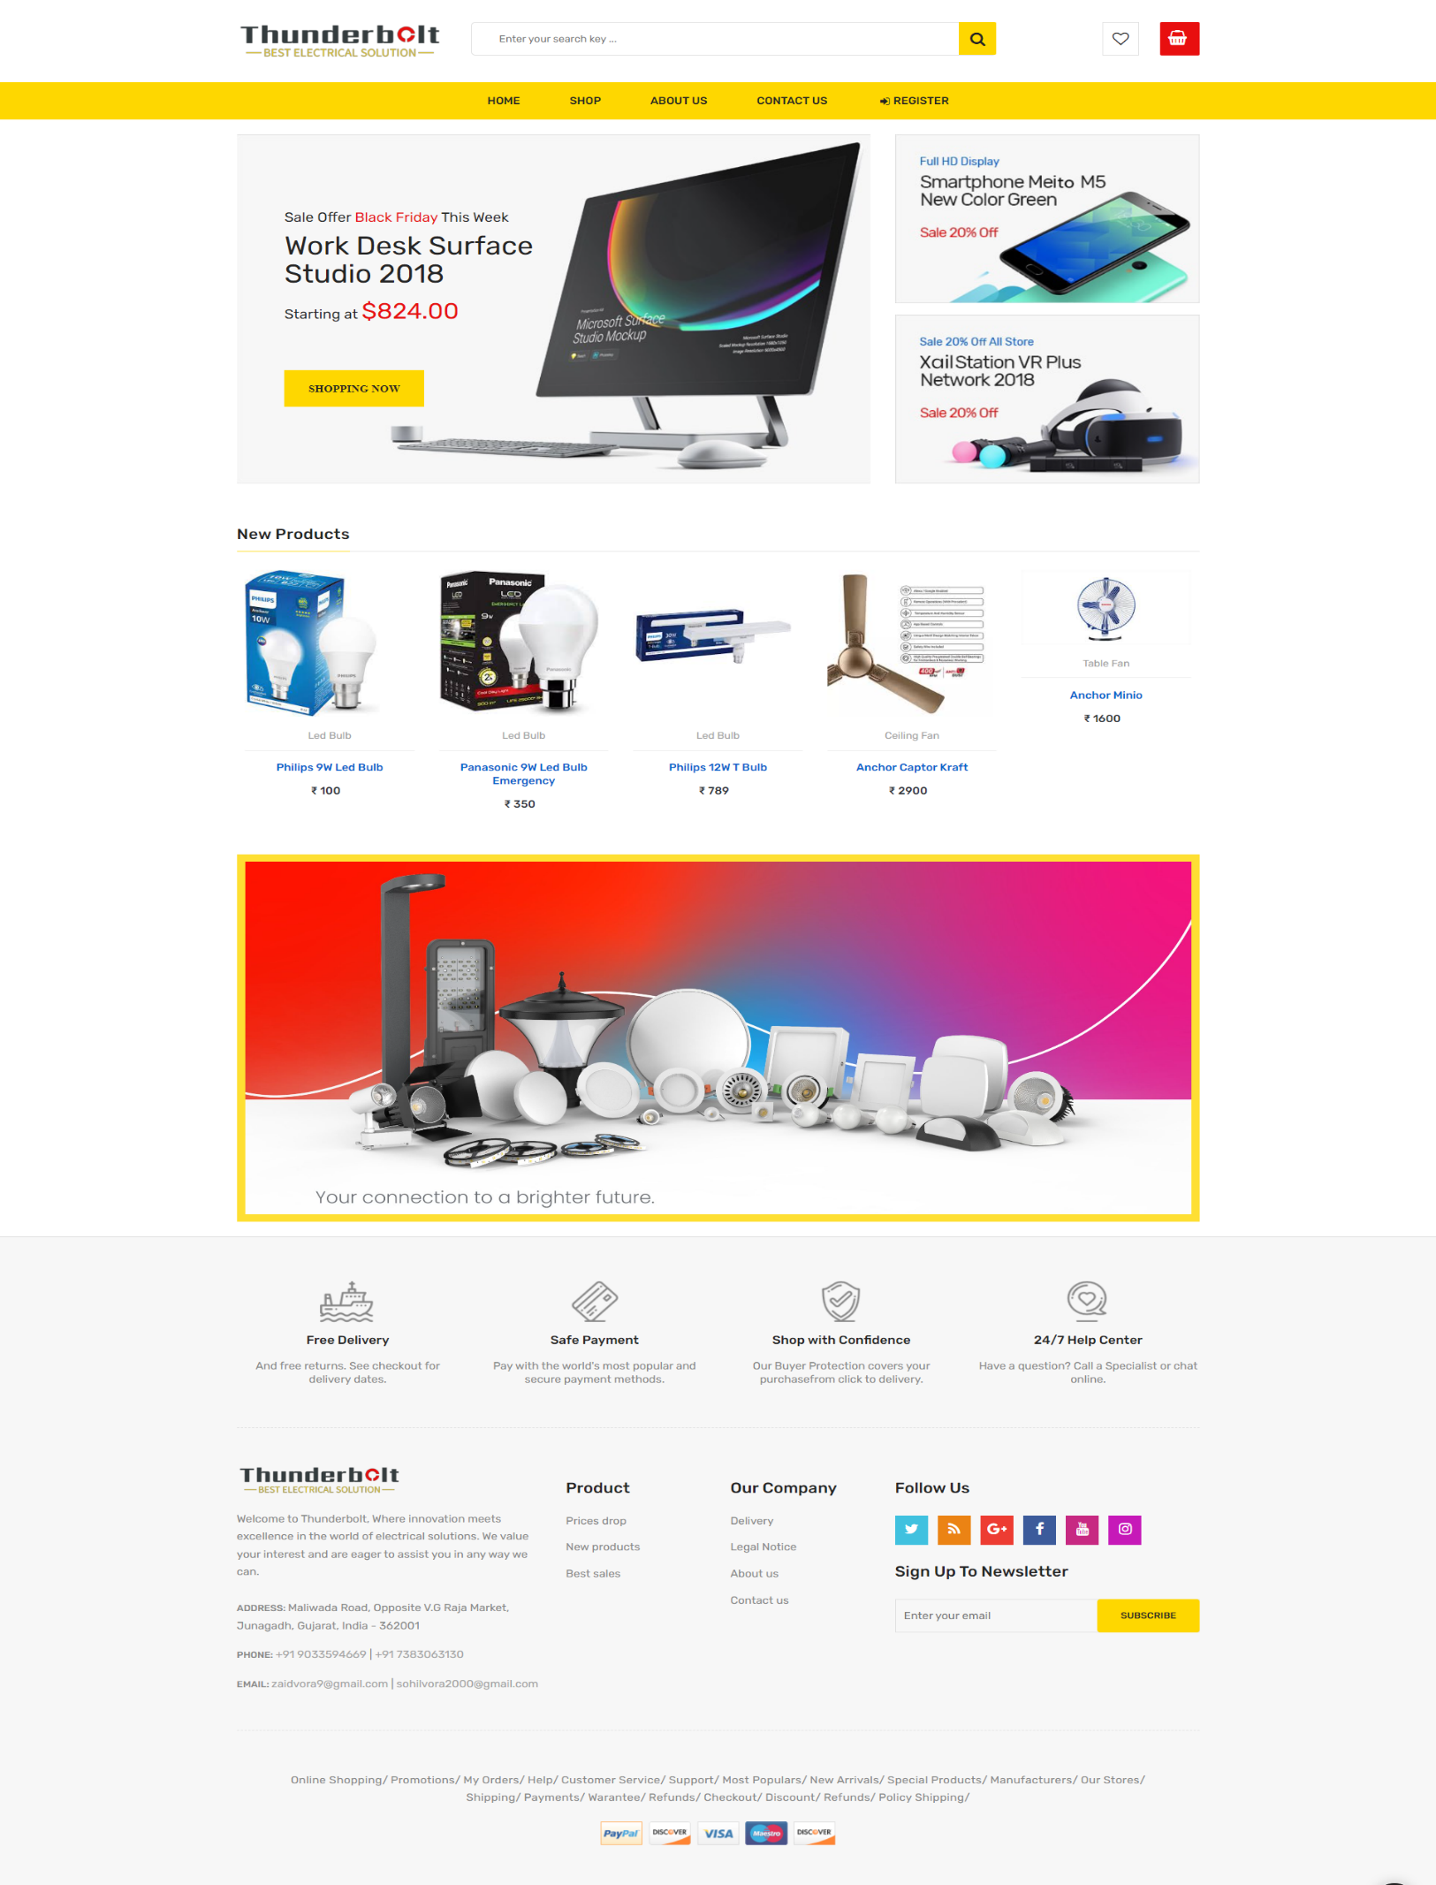

* 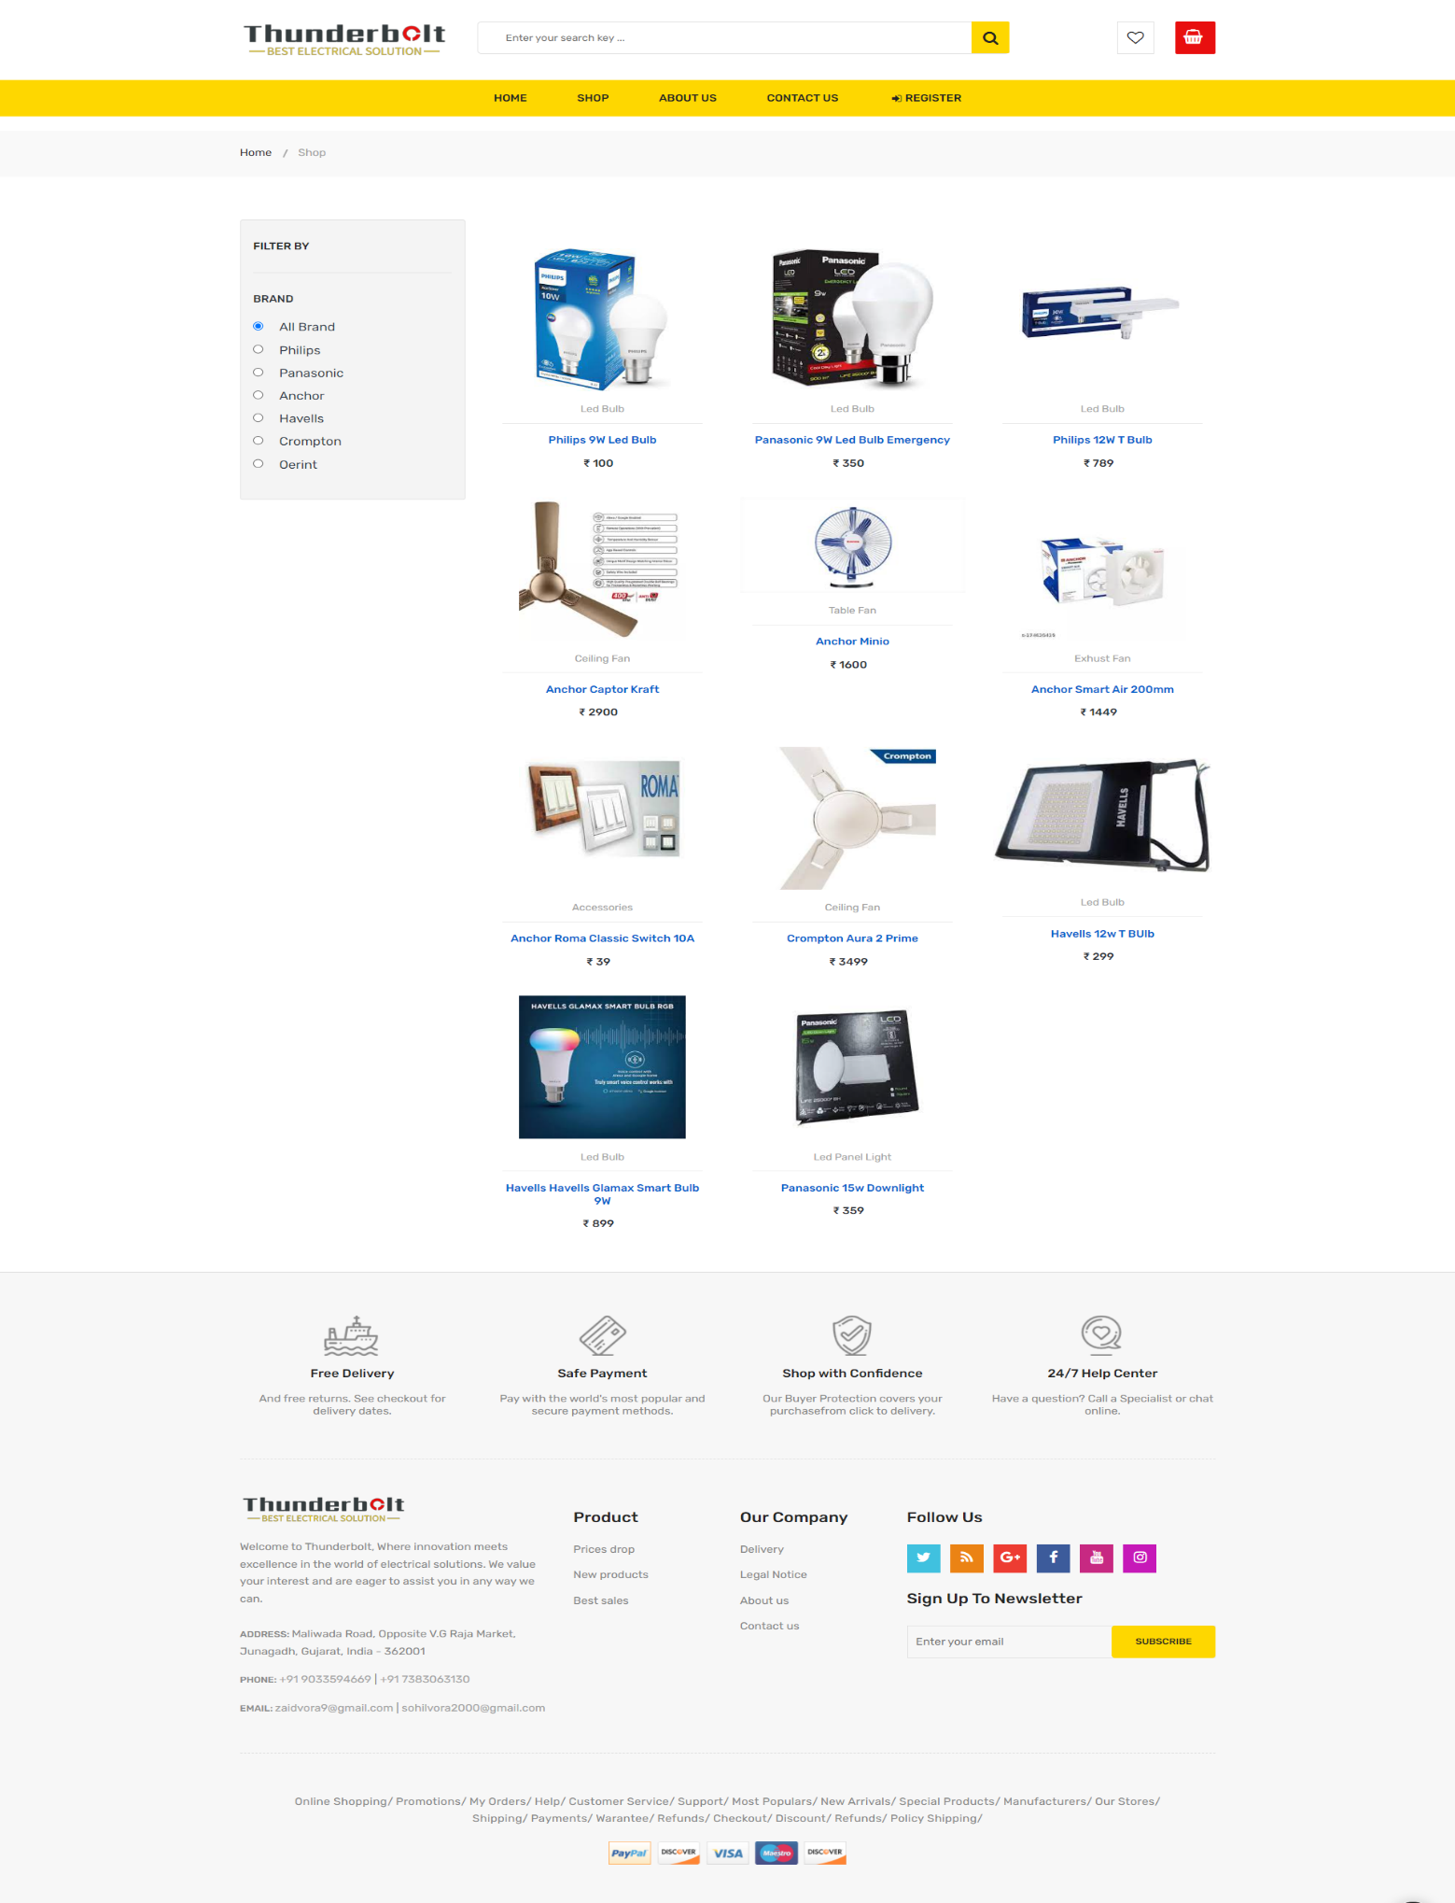 **Visitor – Shop :** This is Shop page of visitor panel
* 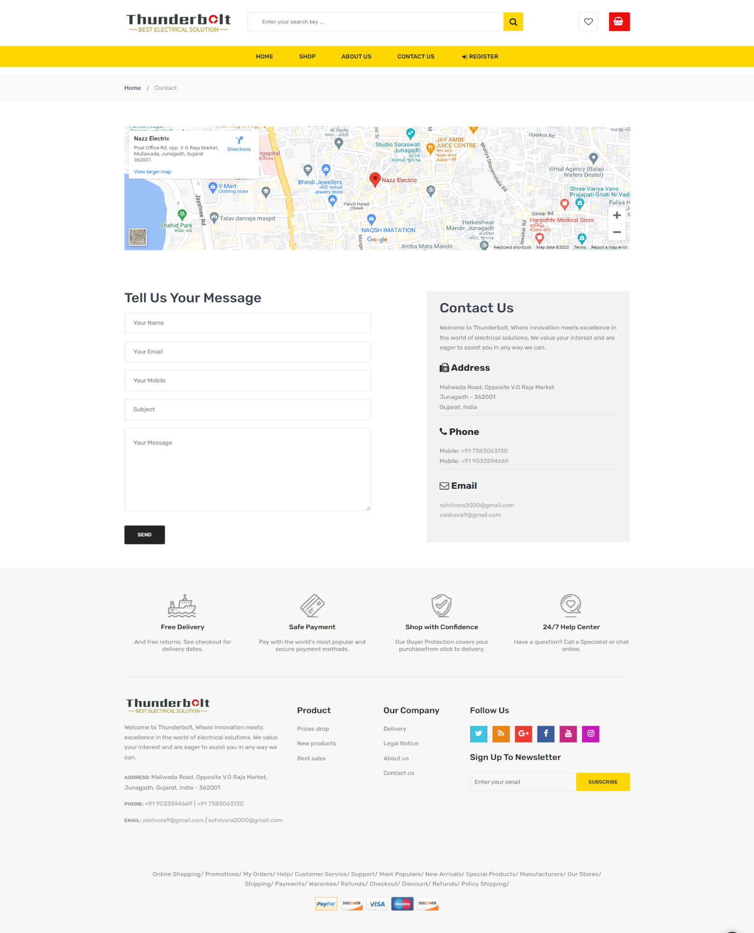 **Visitor – ContactUs :** This is ContactUs page of visitor panel
* 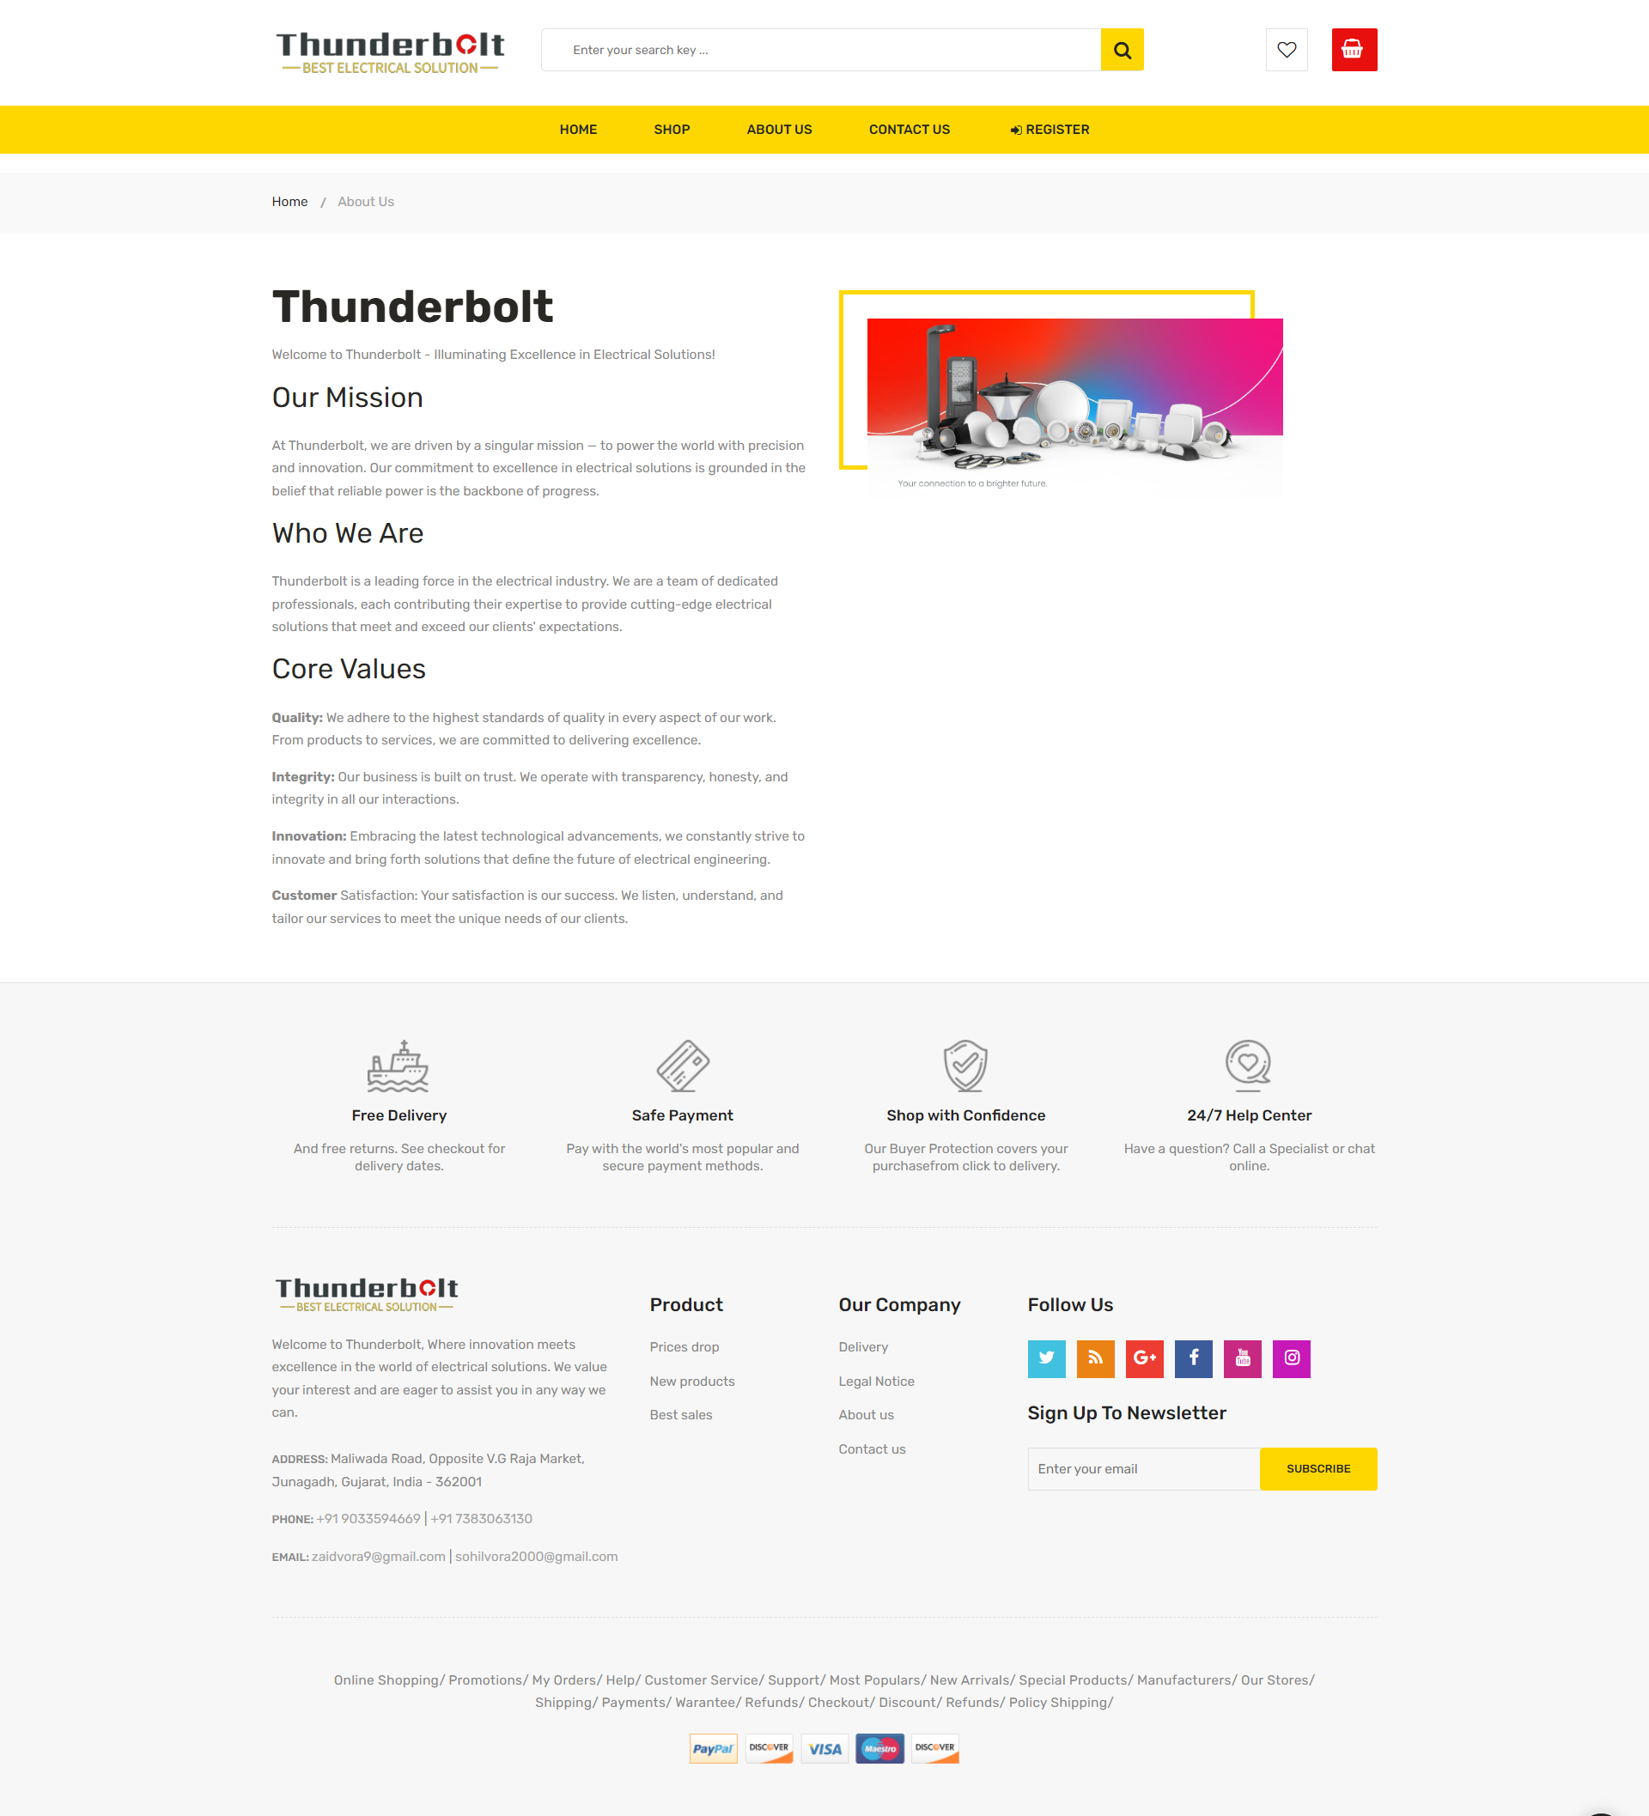 **Visitor – AboutUs :** This is AboutUs page of visitor panel
* **Visitor – Register :** This is Register page of visitor panel

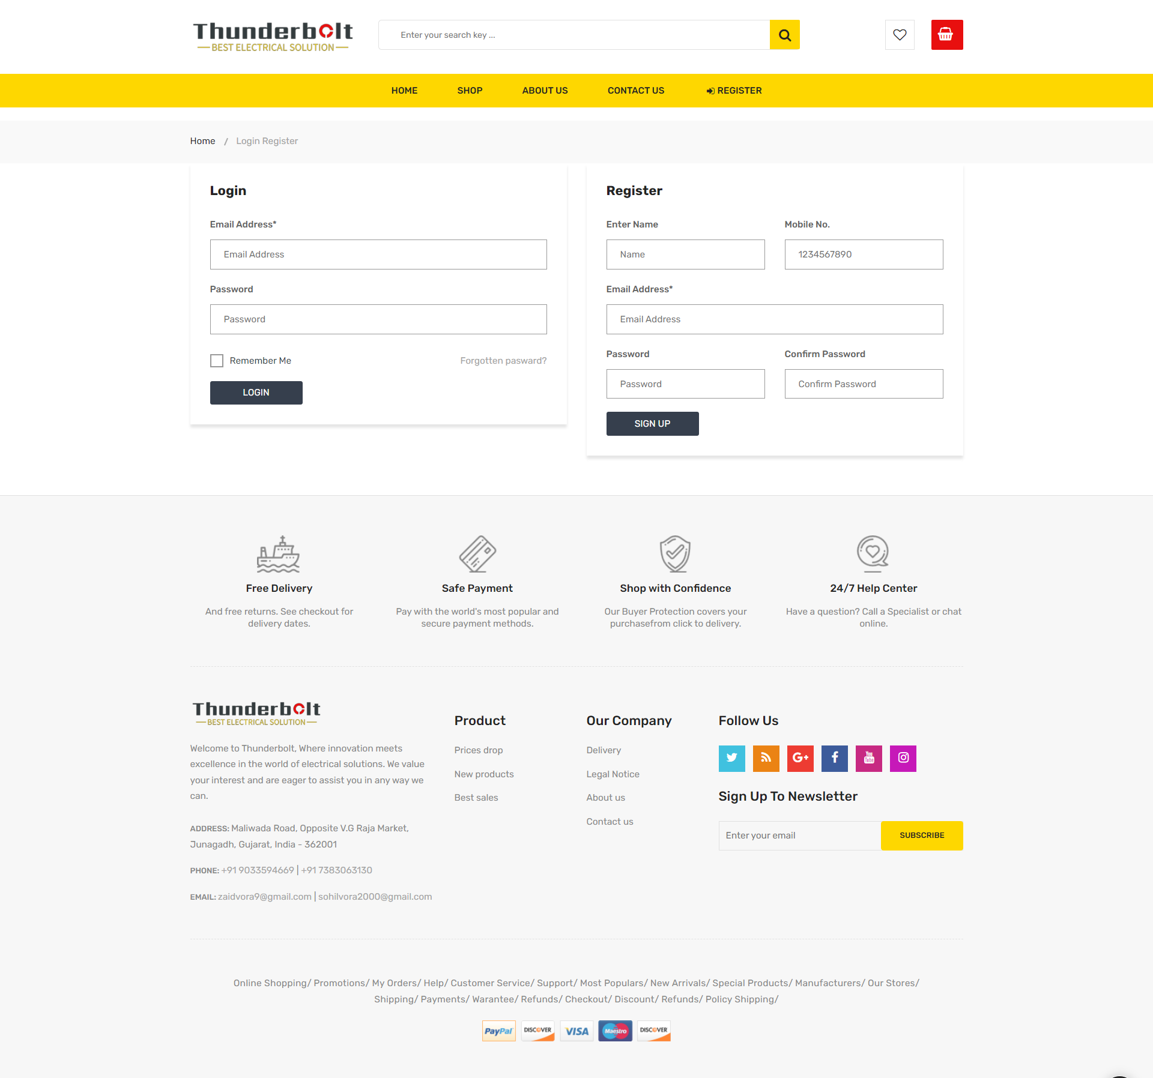

* **User – Index :** This is Home page of User panel

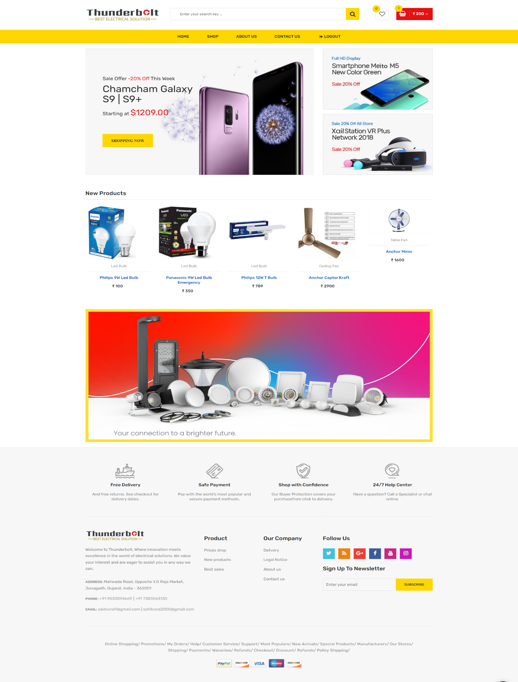

* **User – QuickView :** This is QuickView page of User panel

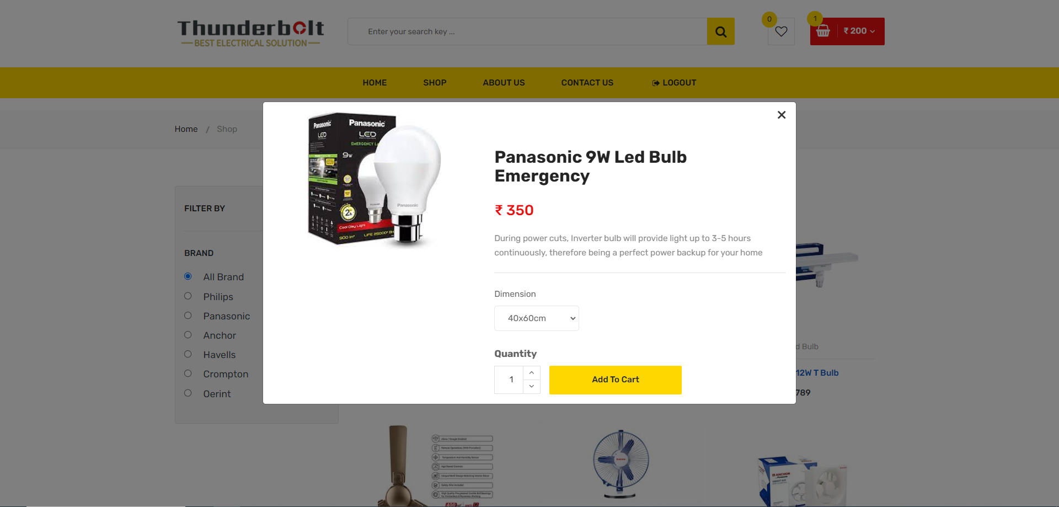

* **User – Add to Cart :** This is Add to Cart page of User panel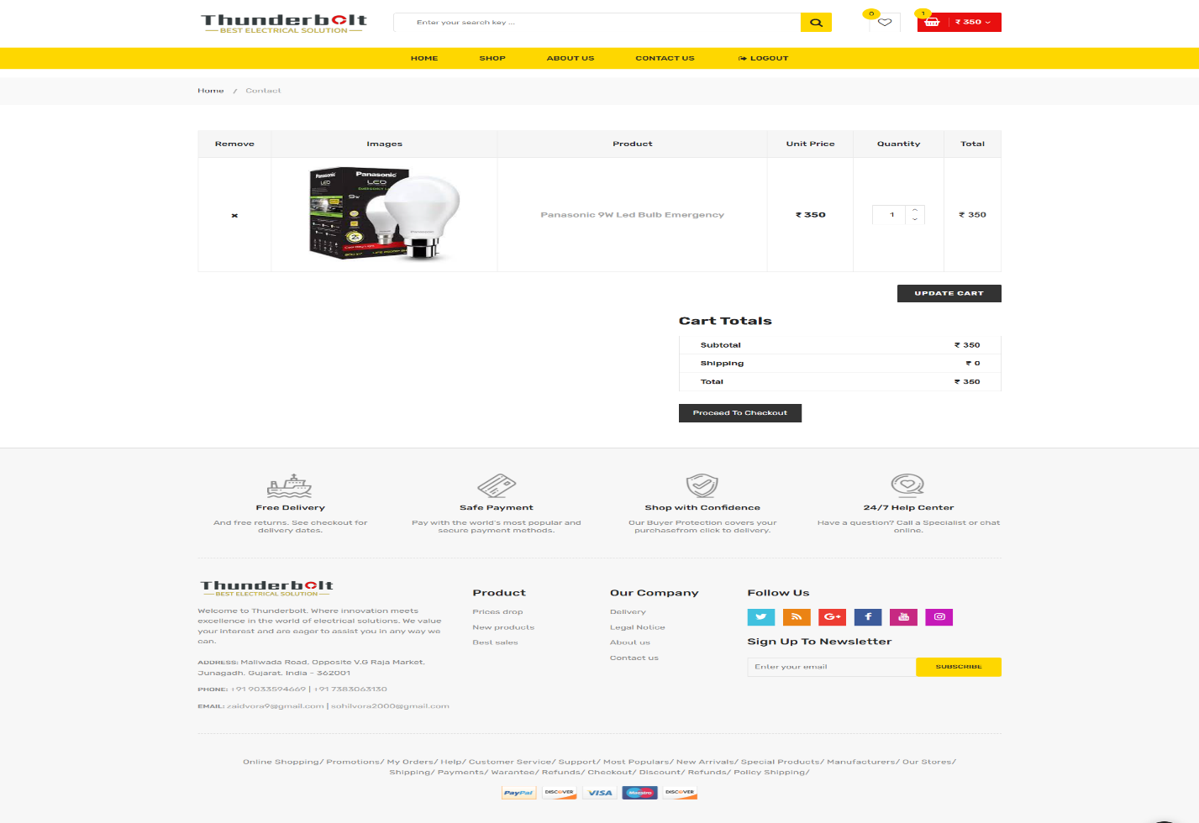
* 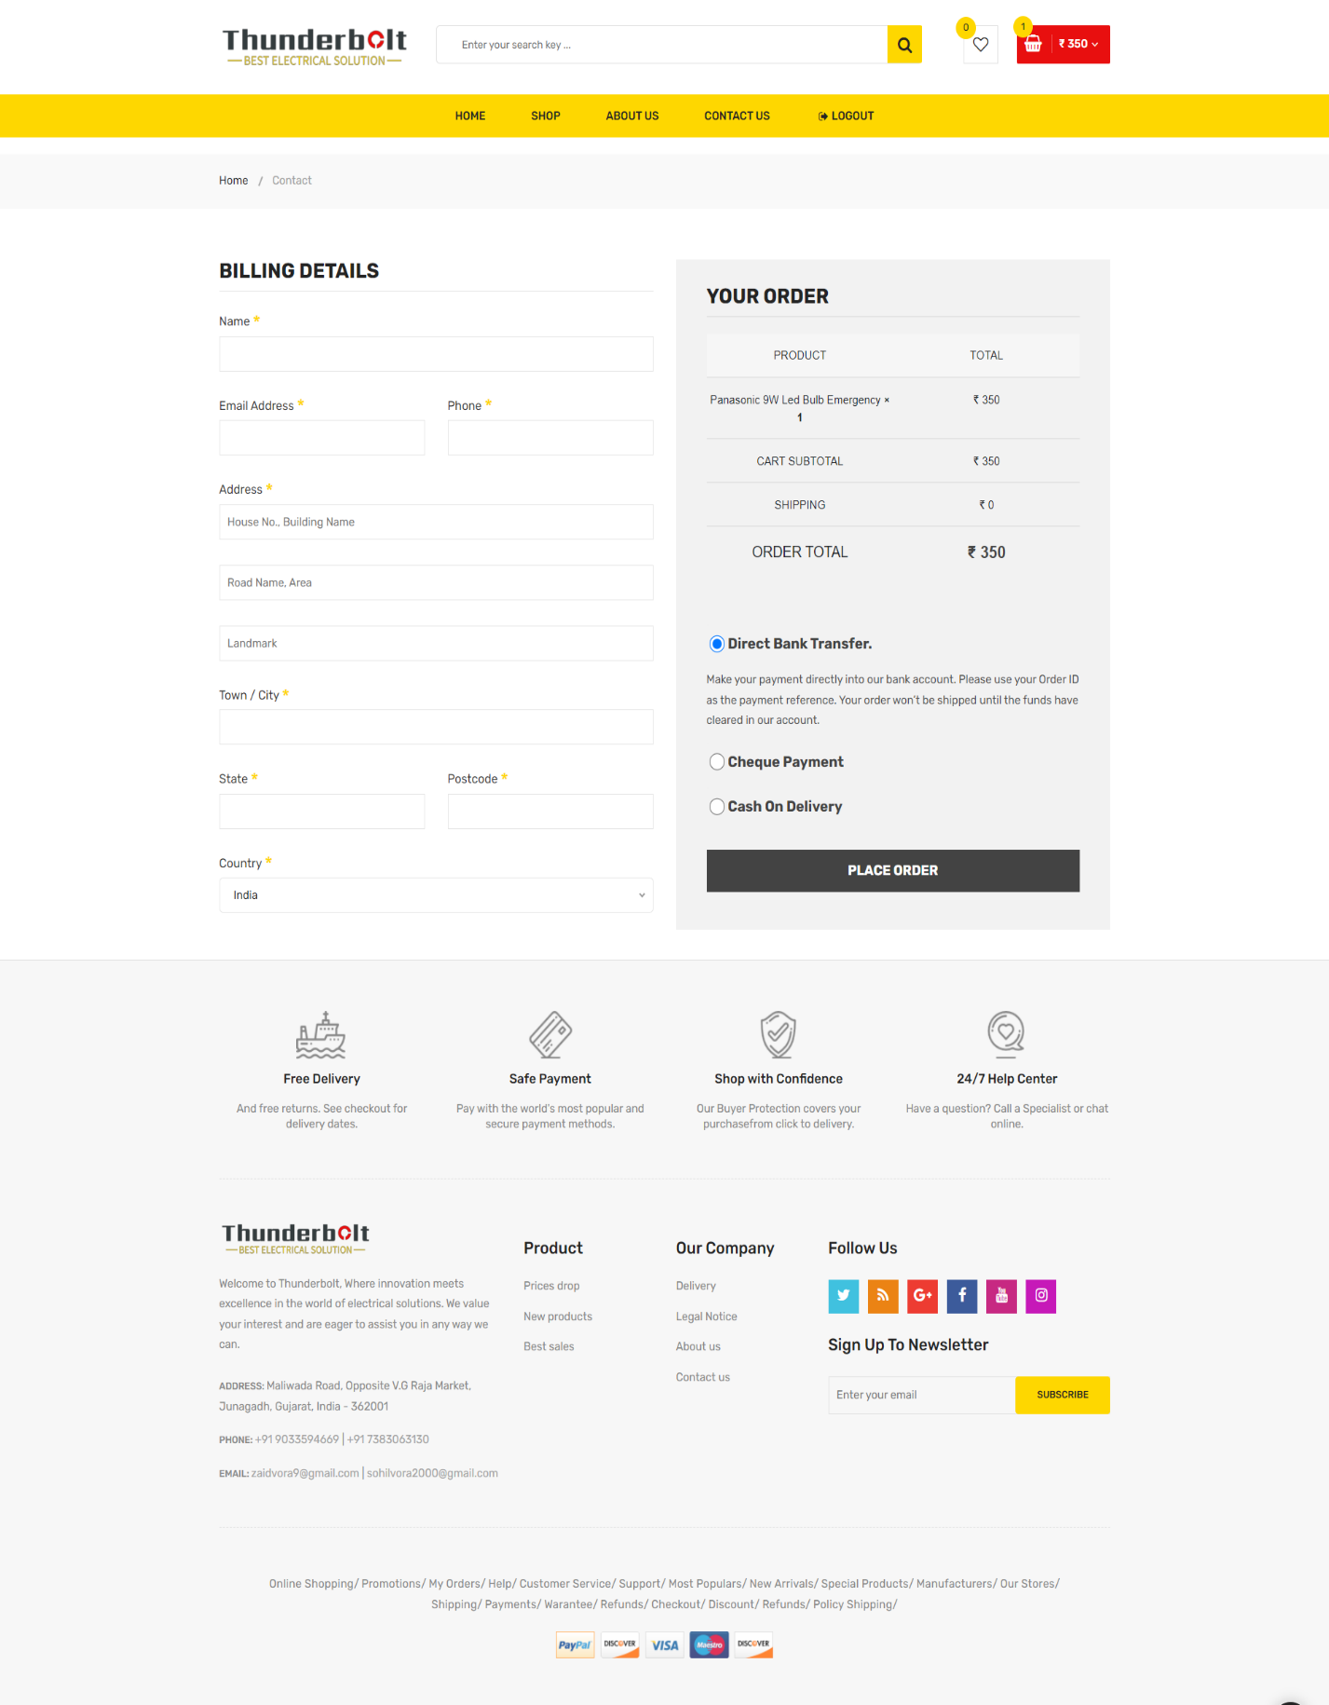**User – Check Out :** This is Check out page of User panel

* **Admin– Index :** This is Home page of Admin panel

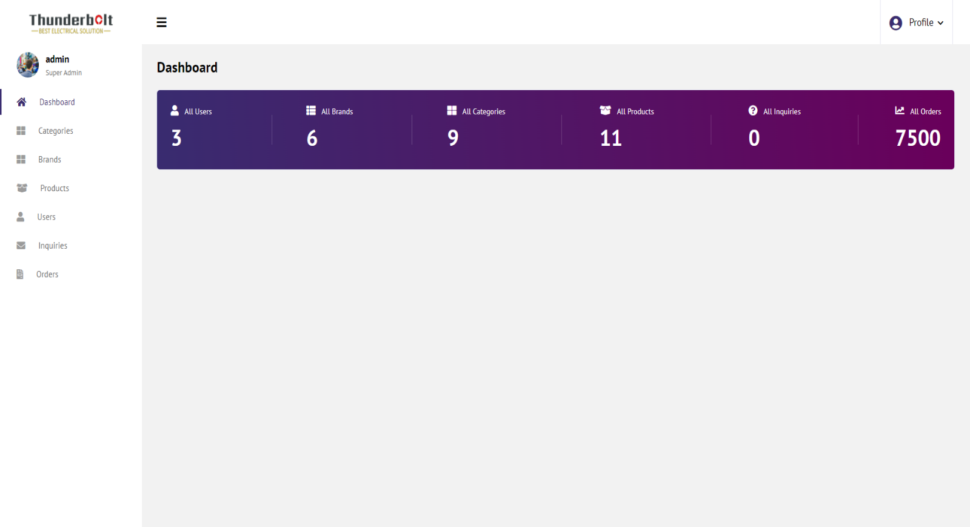

* **Admin– Brands :** This is Brands page of Admin panel

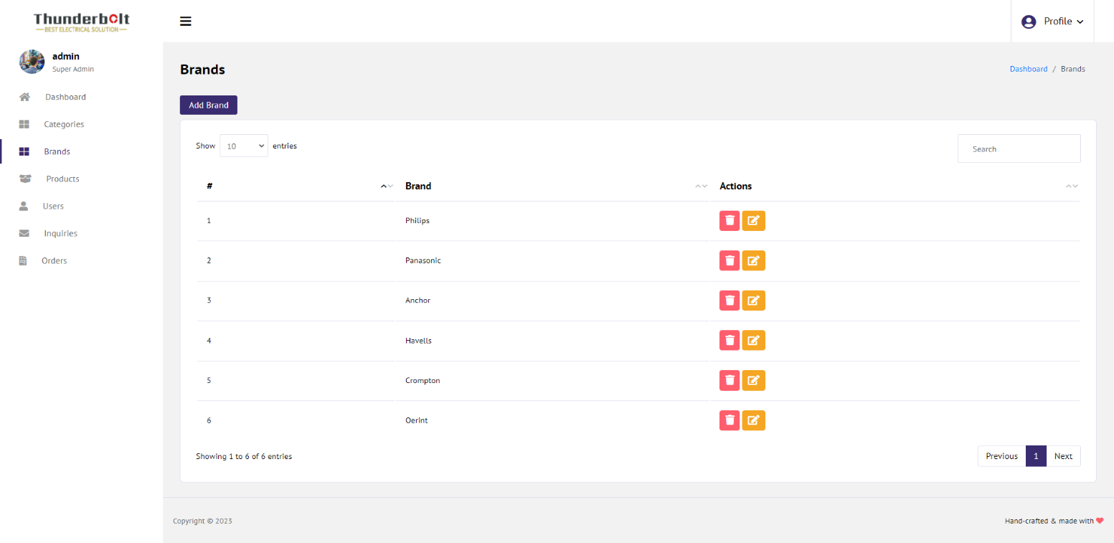

* **Admin– Category :** This is Category page of Admin panel

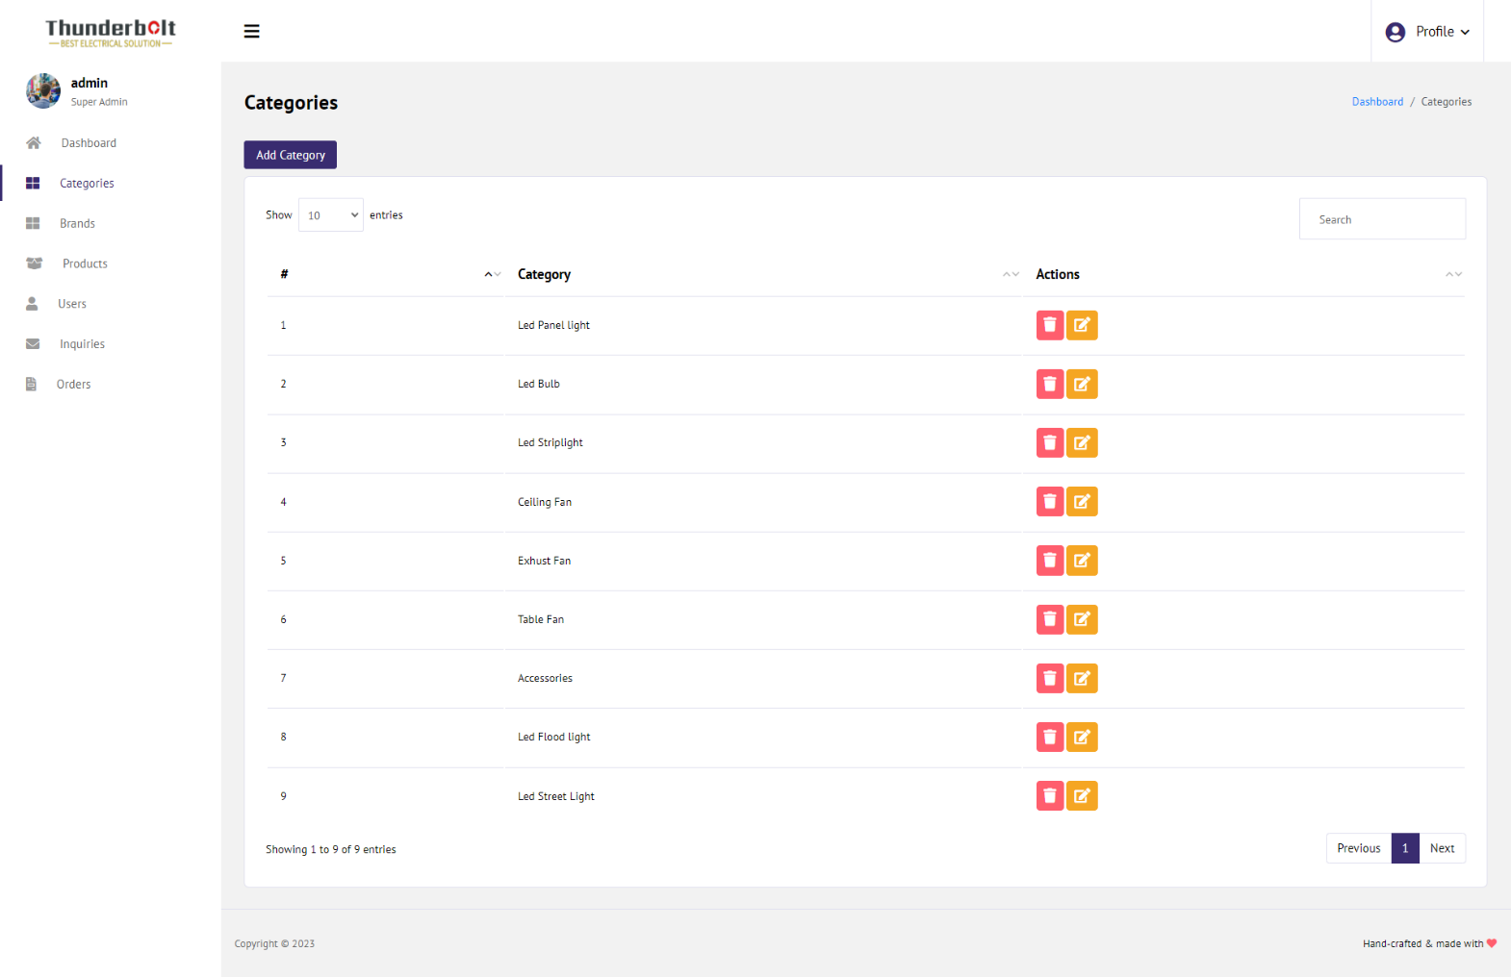

* 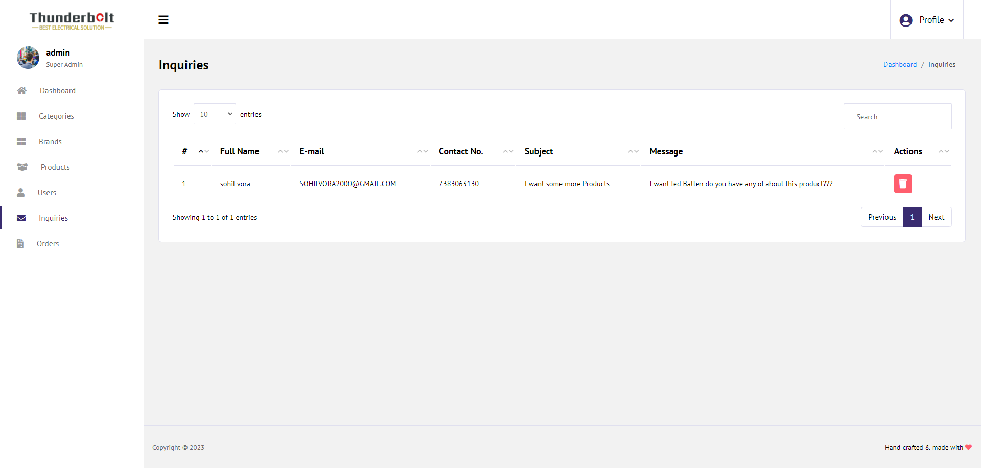**Admin– Inquiry :** This is Inquiry page of Admin panel
* **Admin– Product :** This is Product page of Admin panel

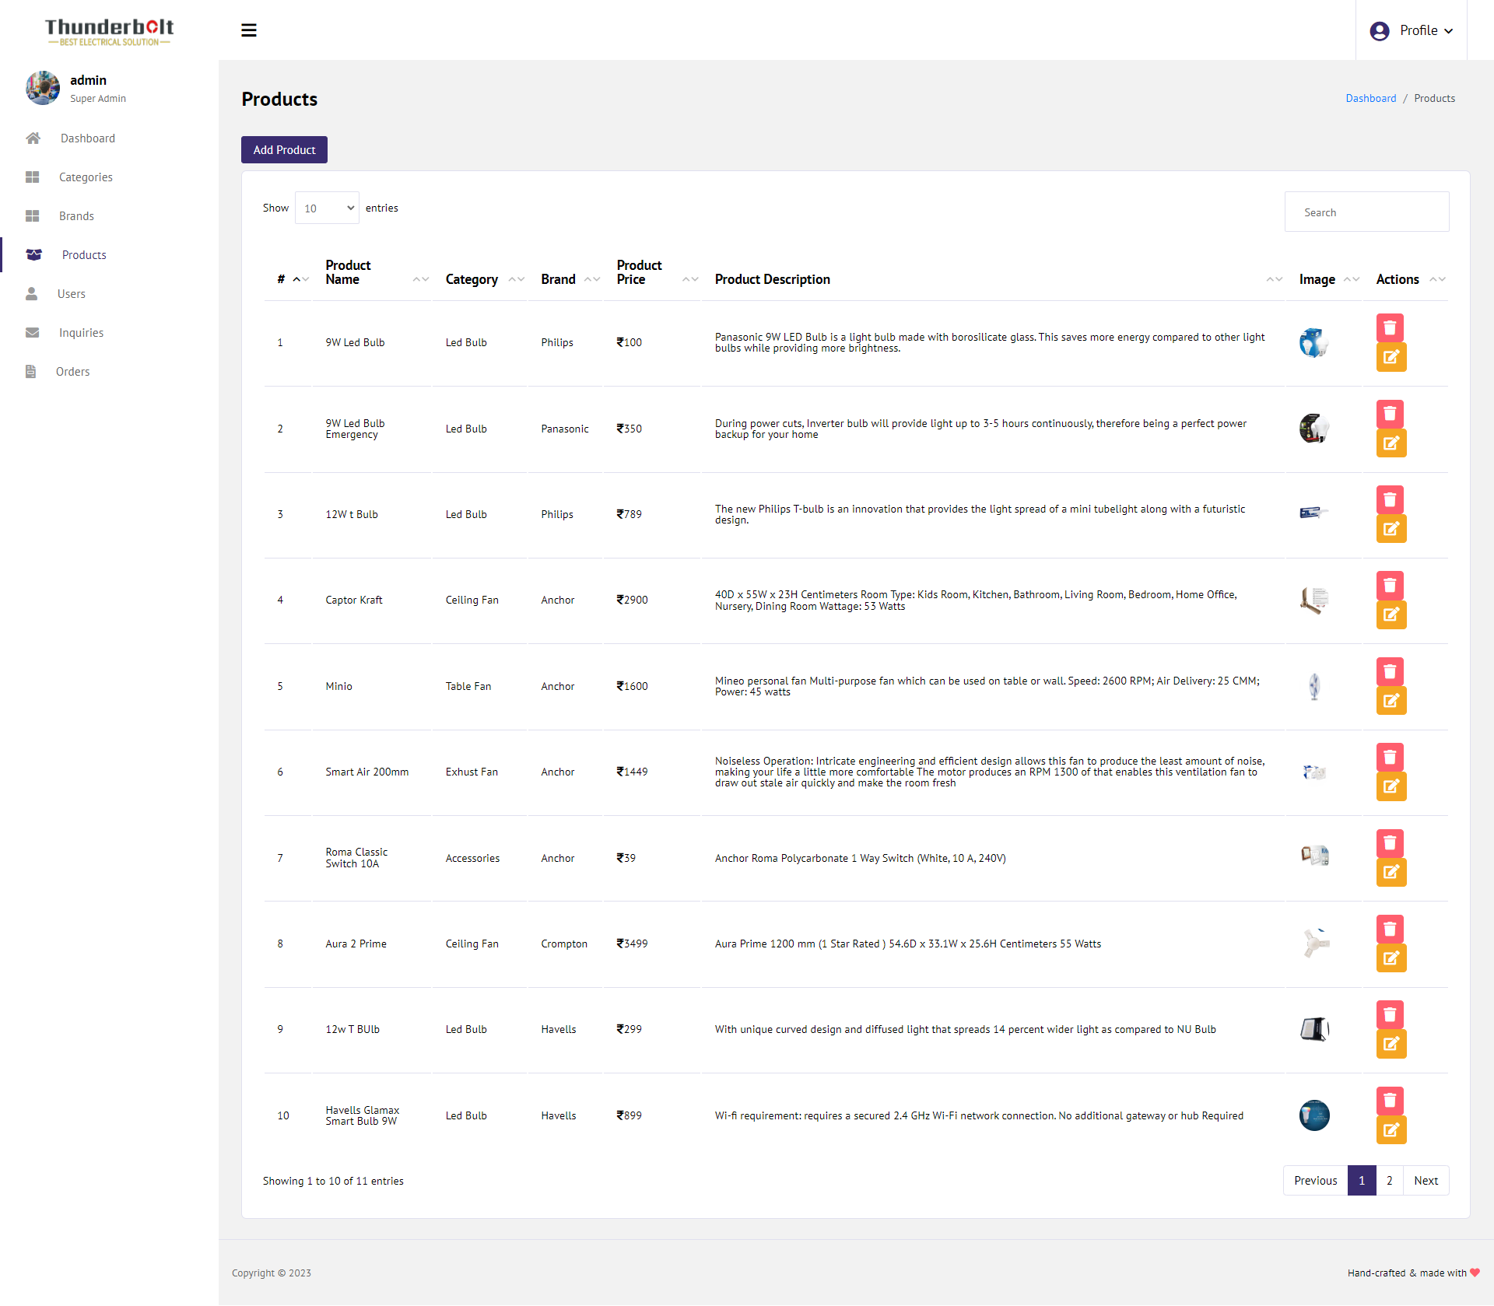

* **Admin– User :** This is User page of Admin panel

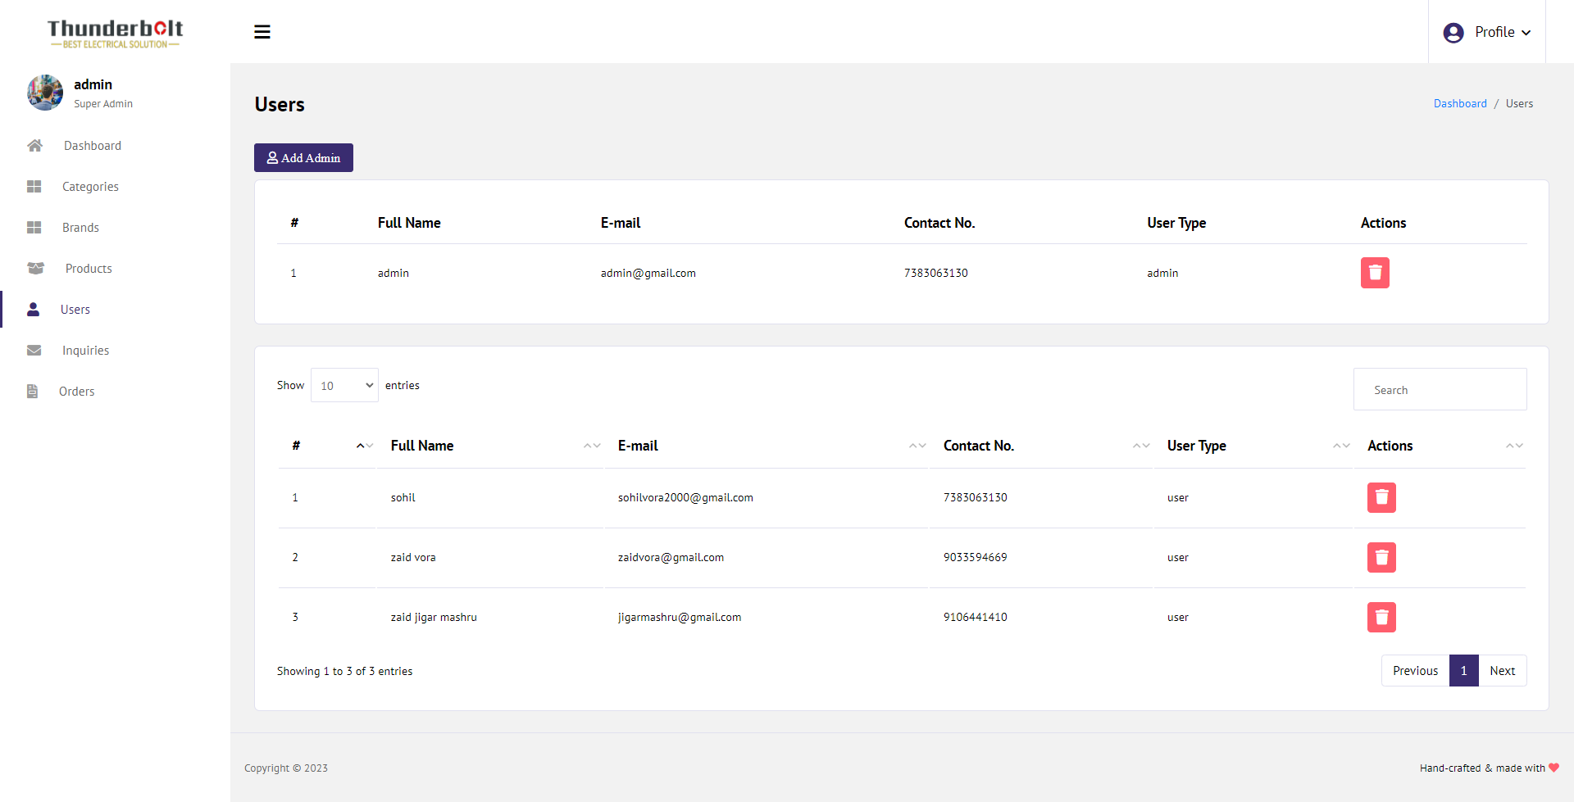

**Chapter – 7 Testing**

7.1 Techniques and Strategies

7.2 Cost Estimation Model

7.3 SDLC Model

7.4 Future Scope and Further Enhancement of Project

7.5 Bibliography

7.6 Appendices

7.7 Glossary

7.1 Techniques and Strategies

Testing is a process to show the corrections of the program. Testing is needed to show completeness, to improve the quality of the software and to provide the maintenance aid. Some testing standards are therefore necessary reduce the testing costs and operation time. Testing software extends throughout the coding phase and it represents the ultimate review of configurations, design and coding. Based on the way the software reacts to these testing. We can decide whether the configuration that has been built is study or not. All components of an application are tested, as the failure to do so many results in a series of bugs after the software is put to use.

1. **Black Box Testing**

This testing methodology looks at what are the available inputs for an application and what the expected outputs are that should result from each input. Black box testing also called behavioral testing, focuses on the functional requirement of software.

This testing approach enables the software engineer to drive the input conditions that will fully exercise all requirements for a program. Black box testing attempts to find the error like….

* Incorrect or missing function.
* Interface errors.
* Errors in data structure or external database access.
* Initialization and termination errors.

1. **White Box Testing**

White box testing is also called Glass box testing is a test case design control structure of the procedural design to derive test cases using white box testing method. This testing methodology looks under the covers and into the subsystem of an application. White-box testing enables you to see what is happening inside the application. The software engineer can drive the test cases that guarantee that all independent paths within the module have been exercised at least once. Exercise all logic decisions on their true or false sides. Execute all loops at their boundaries and within their operational bounds. Exercise internal data structure to ensure their validity.

1. **GrayBox Testing**

Grey box testing involves having knowledge of internal data structure and algorithms for purpose of designing the test cases, but testing at the user, or b9lack box level. Manipulating input data and formatting output do not qualify as grey box, because the input and output are clearly outside of the “black box” that we are calling the system under test. This distinction is particularly important when conducting integration testing between two modules of code written by two different developers, where only the interfaces are exposed for test.

1. **Non-functional Testing**

Non-Functional testing is the testing of a software application for its non-functional requirements. The names of many non-functional tests are often used interchangeably because of the overlap in scope between various non-functional requirements.

For example, software performance is a broad term that includes many specific requirements like reliability and scalability.

1. **Software Testing**

The unit testing is purpose of unit testing is to ensure that each program is fully tested.

The integration testing is individual program units or programs are integrated and tested as a complete system to ensure that the software requirements.

This testing involves planning and the execution of various types of test in order to demonstrate that the implemented software system satisfied the requirements. Finally our project meets the requirements after going through all the levels of testing.

**Cost Objectives**

* **To ensure viability :**

1. Feasibility study
2. Resource planning
3. Cost/benefit analysis

* **Provide input for pricing (including bidding negotiations etc.)**

**To serve as a management tools :**

1. Cost Control and Management
2. Risk management
3. Budget planning

* **Criteria for good project costing**

1. Accurate
2. Realistic (good procurement and engineering practice)
3. Consistent
4. Transparent
5. Cost-effective
6. Good Documentation

**Project Costing**

Many look upon project testing as a cost. While it is true that software testing does cost money, in many cases significant amounts of money, it is also an activity that an organization to avoid costly failures further on in the development process.

Most understand this relationship; project testing is spending money to save money. What many do not also realize is that software testing also produces valuable assets for the organization. This article will discuss those assets of software testing.

**Cost Estimation**

Working time estimation is as given,

2 months + 05 days / month = 65 days

5 hour / day = 340 hours

Now, the expenses & cost estimation are given below :

Computer rent = 5,000 /-

+ Light Bill Rs. 8.50 / unit

Worth 200 units = 1,700 /-

+ Database design & creation = 2,500 /-

+ Coding & Validation = 3,000 /-

Amount = 12,200 /-

- Late Discount = 200 /-

Total = 12,000 /-

7.3 SDLC Model

**Waterfall Model**

The Waterfall Model was first Process Model to be introduced. It is also referred to as a linear-sequential life cycle model. It is very simple to understand and use. In a waterfall model, each phase must be completed before the next phase can begin and there is no overlapping in the phases. Waterfall model is the earliest SDLC approach that was used for software development. The waterfall Model illustrates the software development process in a linear sequential flow; hence it is also referred to as a linear-sequential life cycle model. This means that any phase in the development process begins only if the previous phase is complete. In waterfall model phases do not overlap.

**Waterfall Model Design**

Waterfall approach was first SDLC Model to be used widely in Software Engineering to ensure success of the project. In "The Waterfall" approach, the whole process of software development is divided into separate phases. In Waterfall model, typically, the outcome of one phase acts as the input for the next phase sequentially. Following is a diagrammatic representation of different phases of waterfall model.

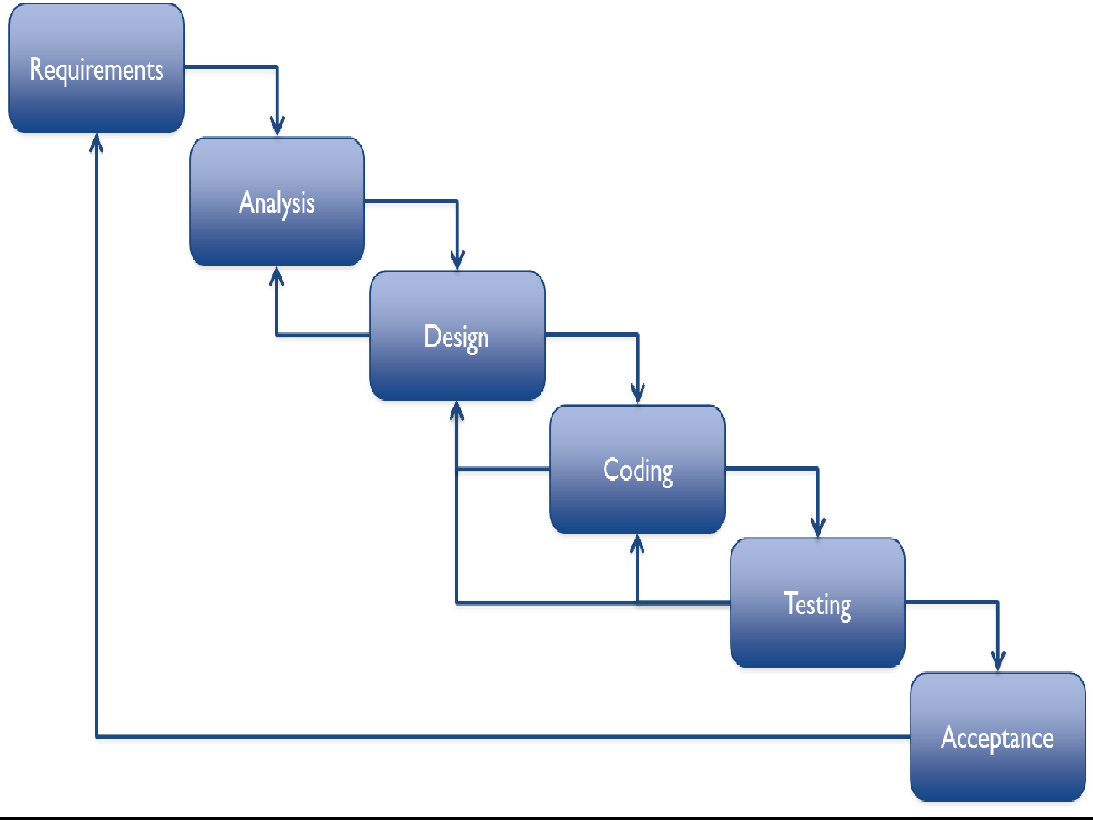

**Iterative Model**

In Iterative model, iterative process starts with a simple implementation of a small set of the software requirements and iteratively enhances the evolving versions until the complete system is implemented and ready to be deployed. An iterative life cycle model does not attempt to start with a full specification of requirements. Instead, development begins by specifying and implementing just part of the software, which is then reviewed in order to identify further requirements. This process is then repeated, producing a new version of the software at the end of each iteration of the model.

**Iterative Model Design**

Iterative process starts with a simple implementation of a subset of the software requirements and iteratively enhances the evolving versions until the full system is implemented. At each iteration, design modifications are made and new functional capabilities are added. The basic idea behind this method is to develop a system through repeated cycles (iterative) and in smaller portions at a time (incremental).

* Following is the pictorial representation of Iterative and Incremental model:

Requirements

Planning

Analysis

Coding

Designing

Implementation

Testing

Testing

Testing

Testing

Testing

Testing

Testing

Implementation

Implementation

Implementation

Implementation

Implementation

Implementation

**V Model**

The V - model is SDLC model where execution of processes happens in a sequential manner in V-shape. It is also known as Verification and Validation model. V - Model is an extension of the waterfall model and is based on association of a testing phase for each corresponding development stage. This means that for every single phase in the development cycle there is a directly associated testing phase. This is a highly disciplined model and next phase starts only after completion of the previous phase.

**V Model Design**

Under V-Model, the corresponding testing phase of the development phase is planned in parallel. So there are Verification phases on one side of the .V. and Validation phases on the other side. Coding phase joins the two sides of the V-Model. The below figure illustrates the different phases in V-Model of SDLC.

**Spiral Model**

The spiral model combines the idea of iterative development with the systematic, controlled aspects of the waterfall model. Spiral model is a combination of iterative development process model and sequential linear development model i.e. waterfall model with very high emphasis on risk analysis. It allows for incremental releases of the product, or incremental refinement through each iteration around the spiral.

**Spiral Model Design**

The spiral model has four phases. A software project repeatedly passes through these phases in iterations called Spirals.

**Identification**

This phase starts with gathering the business requirements in the baseline spiral. In the subsequent spirals as the product matures, identification of system requirements, subsystem requirements and unit requirements are all done in this phase.

This also includes understanding the system requirements by continuous communication between the customer and the system analyst. At the end of the spiral the product is deployed in the identified market.

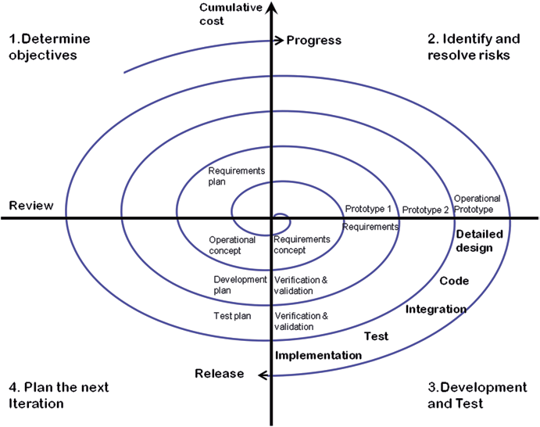

**Prototype Model**

The basic idea here is that instead of freezing the requirements before a design or coding can proceed, a throwaway prototype is built to understand the requirements. This prototype is developed based on the currently known requirements. By using this prototype, the client can get an “actual feel” of the system, since the interactions with prototype can enable the client to better understand the requirements of the desired system. Prototyping is an attractive idea for complicated and large systems for which there is no manual process or existing system to help determining the requirements. The prototype is usually not complete systems and many of the details are not built in the prototype. The goal is to provide a system with overall functionality.

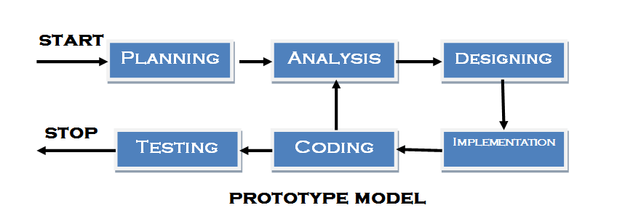

7.4 Future Scope and Further Enhancement of Project

* Any new facility can be added in this project.
* Add new web page and admin panel in it.
* It is possible to make changes in it.
* More database security can be added.
* When the requirement of any new web page than develop it.
* Admin Can Reply of Inquiry.
* Admin can see More data about sales
* In future many payment method will added.

7.5 Bibliography

For the successful working of my project I have referred many sources for the code snippets, logic and tips and tricks from the various books as well as web sites. Most I searched for the required possessions on the google.com search engine.

* **PHP:**
* Publication Name: Sun Microsystems.
* PHP Manual Download

Link:-<https://docs.oracle.com/en/java/>

* **MySQL:**
* Author Name: - 1) SHELDON ROBERT

2) MOES, GEOFF.

* **Web Link:**
* www.google.com
* [www.w3schools.com](http://www.w3schools.com)
* <https://getbootstrap.com/docs/4.6/getting-started/introduction/>

7.6 Appendices

The project of “**Thunderbolt**” is the customize the working in a online sharing their content. The software take care of all requirement of a Post, share their idea globally.

Finally I would like to thank our project guide **“Mr. Uday Shah”.** Who give us helpful guidelines for our project. He had also given suggestion when difficulties raised in our project.

7.7 Glossary

|  |  |
| --- | --- |
| Full Form | |
| D.F.D. | Data Flow Diagram |
| S.R.S. | Software Requirement Specification |
| E.R. | Entity Relationship |
| P.E.R.T. | Program Evaluation and Review Technique |
| S.D.L.C | Software Development Life Cycle |
| J.S.P | Java Server Page |
| C.S.S | Cascading Style Sheet |
| H.T.M.L. | Hyper Text Markup Language |
| C.U.I. | Console User Interface |
| D.B.M.S. | Data Base Management System |
| G.U.I. | Graphical User Interface |

